The Battle
Of
Baton Rouge
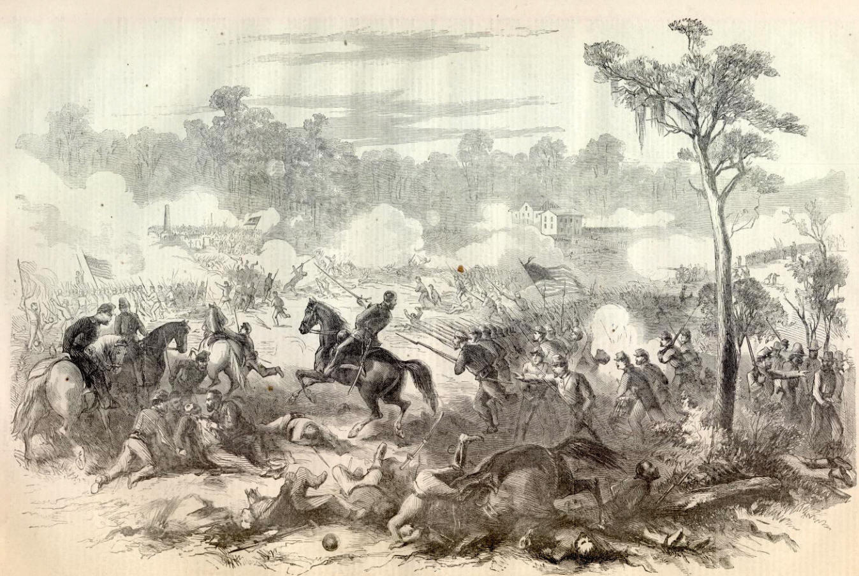
By SFC Daniel O’Connell

Battle of Baton Rouge – Prelude The spring of 1862 was a time of much command confusion for the Confederate armies in the west. The Battle of Shiloh had removed the Confederate commander designate, Albert Sidney Johnston, and placed the remaining senior officer under a cloud of suspicion. The death of Johnston had thrust command onto P. G. T. Beauregard at a critical juncture. When the badly damaged and tangled forces could not maintain the promising first day results the apparent victory turned into defeat and a scapegoat had to be found. President Jefferson Davis set his scornful eye squarely on Beauregard. When he abandoned Corinth to the Union forces under MG Henry Halleck without a fight Davis relieved him of command in favor of Braxton Bragg. Bragg immediately set out to reorganize the army and reinstitute discipline. Bragg’s restructuring of the command put some new faces in some important places.
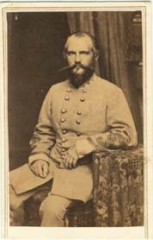
BG John Forney was an 1848 graduate of west Point who commanded the District of the Gulf. His primary responsibility was the defense of Mobile. The importance of this mission precluded him from heavy involvement in the events in Mississippi and Louisiana.
After the retreat from Corinth, Major General Sterling Price departed Tupelo, Mississippi for Richmond to seek command of the Trans-Mississippi Department as the replacement for MG Earl Van Dorn. Confederate President Davis, however, would not buckle to the pressure being applied by the Congressional delegations from Arkansas and Missouri to accept Price’s request for that position. Davis was partial to West Point trained officers and instead handed the job to MG John Magruder. A flabbergasted Price offered his resignation to the executive stating that he would return home to Missouri and raise a new army and win battles for the south there. The threat left Davis unfazed. He told Price that he would please and surprised if he did just that. Nevertheless, the resignation was returned when Davis realized that if Price left the valuable troops he commanded would more than likely follow him back to Missouri. The disappointed Price returned to duty in Mississippi where he was elevated to commander of the District of Tennessee.
BG John Forney
Major General Earl Van Dorn was shuffled downward to the command of the District of Southern Mississippi and Eastern Louisiana where he took charge of the defense at Vicksburg. The diminutive Van Dorn appeared every bit a military leader. The handsome Mississippian cut a figure that some thought “gave assurance of a man whom men could trust and follow” but others thought personal glory was his primary objective. The West Point graduate served during the Mexican War where he gained the notice of Jefferson Davis. The future Confederate President recommended his brevet promotion to captain. Secretary of War Davis had also helped get a choice assignment on the Texas frontier for Van Dorn. But being on friendly terms with the President could not help him now. Van Dorn’s image had been badly tarnished by a poor performance during the defeat at Pea Ridge. Although the new assignment amounted to a reduction Van Dorn still held an independent command and he was eager to rebuild his reputation.
Also included in the mix was MG Edmund Kirby Smith, commander of the Department of East Tennessee, who was expected to cooperate with Bragg in securing the region. It was a head strong group of highly independent men. Gaining coordination and cooperation between the members of this group would severely test the command skills of Bragg. In this command climate a series of Confederate operations was begun to win back lost ground. The first of these would be an attempt to take back the Louisiana capital – Baton Rouge.
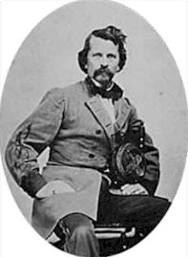
Vicksburg to Baton Rouge The probability of a clash at Baton Rouge grew out of the easy progress up the Mississippi River by MG Benjamin Butler’s troops from the south. Following the capitulation of New Orleans on 1 May 1862 Butler made an aggressive push up the river to the capital. Union naval forces took possession of the arsenal and barracks at Baton Rouge bloodlessly on May 9th. A week later Natchez also fell without a struggle. Encouraged by these early gains Butler moved BG Thomas Williams’ brigade north with the fleet with an eye to further expansion along the river. Coupled with success north of Vicksburg the complete control of the river could be had with the surrender of that city. Expecting another easy victory Butler sent Commander Stephen P. Lee and BG Williams to claim the prize. On 13 May Williams boarded the 6th Michigan and the 4th Wisconsin onto the Laurel Hill and Ceres for the trip up the river to Vicksburg. The Union fleet arrived to demand the surrender of the city on May 26th but was steadfastly refused by the garrison commander. BG Martin Luther Smith announced in his refusal that he had been ordered to defend the city and he intended to do so “as long as it is in my power.” Three factors contributed to the decision to abandon this effort at the city.
MG Earl Van Dorn
1. The resolve of the defenders 2. The elevation restriction of the guns on board the naval vessels did not allow them to put effective fire on the Confederate batteries. 3. The river was at flood stage and the land forces could not be landed. Confinement on the transports had caused the health of the troops to decline.
The expedition returned to Baton Rouge on the 29th and Williams took up a permanent occupation of the city. During their absence there had been a brief outbreak of violence in the city. When the chief engineer of the USS Hartford, John Kimball, and three men attempted to deliver some laundry to a local washwoman they were fired upon by a force of guerillas. Three of the sailors were injured and Farragut ordered the Hartford and the Kennebec to open fire on the city. The shelling killed one woman and injured three other people. Two people drowned trying to swim away from the barrage. When it was believed the guerilla band had disappeared the shelling stopped. A delegation of citizens rowed out to the Hartford and apologized for the guerilla attack, over which they claimed to have no control, and asked that no more fire be sent into the city. The return of Williams and his men from Vicksburg secured the city and avoided any more such incidents.
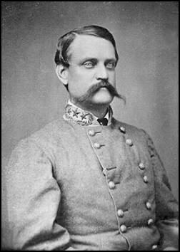
Dissatisfied with the results of the first effort at Vicksburg, Butler again ordered Williams to the fortress city on June 16th. There was a one week delay in the movement while Admiral Farragut assembled the necessary tugs to haul Commodore Porter’s mortar barges up river. The boats finally materialized and the fleet arrived off Vicksburg on the 25th, remaining just beyond the range of the Confederate guns on the far shore. Williams’ force consisted of 3200 men from the 9th Connecticut, 30th Massachusetts, 4th Wisconsin, eight companies of the 7th Vermont, 2nd Massachusetts Battery, and two sections of the 6th Massachusetts Battery (the 6th Michigan, 21st Indiana, one battery and a detachment of cavalry were left behind to secure Baton Rouge). They were put ashore near Desoto Point to begin clearing and grubbing the land for the digging of a canal across the point while the Union fleet (3 ships of war, 10 gunboats, and 19 mortar boats) began a constant shelling of the Confederate defenses. Again, however, circumstances and the river conspired against their efforts. The poorly acclimatized men soon began to fall victim to the heat and malarial conditions. Disgusted at what he perceived as weakness, the grizzled veteran, Williams instituted a harsh program of discipline and drill known as the Order of Combat. When not working on the canal project the men were forced to drill with full packs in the sweltering heat and humidity of a Mississippi summer. The predictable results were a growing sick list and rising death toll. Evidence of the effects of the work and drill were on clear display yet Williams persisted. Fortunately two other events brought an end to the second Vicksburg adventure. The first was the arrival of the Confederate gunboat Arkansas. The armored behemoth fought its way into Vicksburg on July 15th sending Farragut into a near panic over the fate of his fleet. The second was the falling water levels in the river. As the level dropped the viability of the canal project was placed in severe question and was finally stopped. Farragut also used the dropping water as an excuse to depart the area. Fearful that his deep draft vessels would become stranded he decided to abandon the area. Without the support of the fleet Williams refused to stay and the evacuation began on July 25th. By the night of the 26th the last of the Federal troops had returned to Baton Rouge, most heading for the hospital at the Asylum for the Deaf. There would be little opportunity to recover.
MG John C. Breckinridge
Preliminary Operations MG Van Dorn was anxious to mount an attack on the Louisiana capital but the second effort against Vicksburg had stalled his plans. As the Union army and navy threatened the city Van Dorn began to think of the attack on Baton Rouge as a means to draw Federal troops away from Vicksburg. Accordingly, he contacted BG Daniel Ruggles to ascertain the size of the Union garrison at Baton Rouge and an estimate of what might be needed to take the city. Ruggles commanded the only other significant Confederate force in the region, a small division located at Camp Moore.
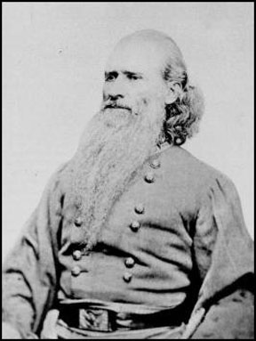
On July 10th Ruggles reported to Van Dorn that he had 1500 men and one battery ready and if he had an additional battery and 3500 troops he could liberate the capital city. In the days following this report Ruggles received intelligence that suggested the Union garrison had been reinforced by 2200 troops that were being brought up from New Orleans to begin operations against Madisonville, Louisiana. When these reports were forwarded to Van Dorn he had no choice but to delay the planned offensive again. Following the triumphant entry of the Arkansas into Vicksburg Van Dorn renewed his interest in the move on Baton Rouge. The two men exchanged a series of telegrams again trying to arrive at the strength of the defense and the number of troops required to regain the capital. When the Federals sailed away from Vicksburg on the 24th of July Van Dorn was free to more vigorously pursue his project. At that time Ruggles had supplied an accurate estimate of the defenses in Baton Rouge (3 infantry regiments, two batteries, and 100 cavalry) and requested “2,000 disciplined troops and one light battery” to reinforce him for the effort. Van Dorn promised more. He telegraphed Ruggles on the 25th that he was sending 4,000 troops and a battery. Reacting to what appeared to be a significant reinforcement of the area (in fact the return of Williams worn out troops from Vicksburg) Ruggles again wrote to Van Dorn stating that 4,000 would not be enough under the new circumstances. Van Dorn sent a message to Sterling Price requesting one brigade to assist in the venture. Braxton Bragg, however, had another operation in mind and refused permission to Price to reinforce Van Dorn. Before receiving the negative reply Van Dorn ordered MG John C. Breckinridge to move two of his three brigades to Camp Moore and unite with Ruggles for the attack on Baton Rouge.
The Confederate troops at Vicksburg had been no less susceptible to sickness and disease than their Union counterparts. Some of the regiments had been reduced to the size of companies and some of the companies almost failed to exist at all. Company E, 20th Tennessee, could muster only four men for the train ride to Tangipahoa, Louisiana. In all Breckinridge managed to load about 4000 men on the trains, however due to the scarcity of cars the men were allowed to carry only their arms, ammunition, and five days rations. The ragged group arrived at Camp Moore on the 28th after suffering a derailment and changing trains in Jackson.
BG Daniel Ruggles
On the 29th a further reduction in the estimate of defenders appeared to make success a good possibility. Breckinridge immediately called a council of his leaders. The combined force was divided into two divisions, each containing two brigades. Ruggles would lead one division, with brigades under the command of Colonel Henry W. Allen and Colonel A. P. Thompson. The second division would be led by BG Charles Clark with brigades commanded by BG Benjamin Helm and Colonel Thomas Smith. The command group voiced serious concerns about the presence of Union gunboats in the river behind the city. Most of them remembered the havoc caused by naval gunfire at Shiloh and wanted no part of a similar experience. Accordingly, Breckinridge contacted Van Dorn seeking the assistance of the CSS Arkansas to clear the river before commencing the operation. Despite the absence of the commanding officer, chief engineer, and the replacement of sick crew members by volunteers from the 1st Tennessee Heavy Artillery the badly beaten up ironclad was ordered to report off Baton Rouge by 5 August. Breckinridge could begin his move to the capital city.
The Federal forces at Baton Rouge were well aware of the Confederate plan to attack the city. Acting on reports from the spy John Mahan, Williams ordered preparations to be made to face the assault. His command had not yet recovered from the failed Vicksburg adventure and many of the units were badly depleted. When the 2nd Massachusetts Battery received their order they could report “only 21 men fit for duty”. To man the important guns “a detail of 30 men” was sent from the 9th Connecticut to fill in the gaps. Lieutenant George Trull “instantly commenced a vigorous drill” to teach the new men the crew drills for the operation of the guns. With the newly arrived “red legs” Trull announced that his six guns were ready for action. The rest of the Union command was doing its best to make ready as well. At the announcement of impending action many of the sick reported back to their units for duty.
Movement to Contact The final Confederate movement to Baton Rouge involved a 60 mile cross country march that was intersected by two major natural obstacles; the Amite and Comite Rivers. Anticipating the cooperation of the Arkansas from Van Dorn, Breckinridge dispatched BG Clark’s division to secure the Williams Bridge over the Amite River at Grangerville on the 31st of July. The Confederate leadership had little faith in the partisans that had been entrusted with the security of the bridge and wanted to ensure that it was not destroyed. Learning that the Arkansas was expected at Baton Rouge on the 5th of August Breckinridge began a forced march to catch up with the advanced party. The two parties reunited on August 2nd and pushed forward to the Comite River about ten miles east of Baton Rouge.
The pace of the march, heat and humidity, and lack of decent water took a serious toll on the Confederate soldiers already weakened by dysentery and malaria. The men, many shoeless and dressed in rags, began to fall out in large numbers. The four men of Co. E 20th Tennessee were reduced by half as one remained on the sick list at Camp Moore and another fell out on the march. One Confederate officer noted in his account of the affair that the men;
“marched in straggling order many of them lank, bent individuals, seemingly hardly able to support , the burden of their blanket rolls and haversacks, but I noticed that their rifles were in perfect order, clean and shining.”
The column was allowed to rest and bathe in the Comite on the afternoon of the 4th. At 2300 the call to form up for the final approach to the city was made. Marching down the Greenwell Springs Road they arrived on the outskirts of Baton Rouge between 0300 and 0400. Breckinridge would write in his OR that he would take 2600 men into battle on the 5th of August, 1862. He promised the men that they would “eat (our) breakfast at the state house.” Many historians have called this estimate into question. By examining the returns and estimating the size of unreported units each researcher has arrived at different numbers but all have concluded that Breckinridge underestimated the strength of his force. Noted Civil War historian Ed Bearss set the number at 3200 counting the 200 partisans, while Thomas Richey, chronicler of the battle, sets the number at 3800. It is possible that writing after the fact of a failed campaign that Breckinridge underestimated his force in an effort to align excuses for the failure.
Waiting for the expected attack Williams had approximately the same number of Union troops. He reported that he had 2500 men for the defense of Baton Rouge but men returning from the sick lists at the possibility of battle probably added significantly to that number. The 14th Maine, 21st Indiana, 7th Vermont, and 30th Massachusetts formed a line of battle in front of their camps. The remaining regiment, the 6th Michigan (missing companies on picket duty) was divided into two battalions. One battalion (Companies A, B, C and F) supported the guns of the 21st Indiana under the command of Captain John Corden. Known as the “Jackass Battery” these three guns, bronze smoothbores, were captured in New Orleans and adopted by the 21st. They were manned by volunteer crews and hauled by mules. The second battalion of Wolverines (Companies G, H, J and I under Captain Charles Clark) was assigned to support the 21st Indiana near the Magnolia Cemetery. The other Union artillery batteries were rounded out by reassigning the caisson drivers to the guns and filling the remaining vacancies with details from the various infantry units. Units were ordered to draw ammunition and rations and to be prepared to resist an attack. As Williams retired to his quarters for the night he felt confident that all that could be done in preparation had been done. He remarked to a staffer before heading to bed that he was sure that the defenders would give a good account of themselves. It would not be long before Breckinridge would test this boast.
While Williams slept the Confederate forces crossed Ward Creek and established themselves in their assault positions. North of the Greenwell Springs Road was General Clark’s 1st division troops , with Smith’s brigade on the far right and Helm’s brigade to their left. Helm’s left fell on the Greenwell Springs Road and was joined by the right of Colonel Thompson’s brigade of Ruggles’ Division south of the road. To Thompson’s left was Colonel Allen’s brigade. Semmes’ battery was established between the two brigades. On the extreme left of the Confederate line a small squadron of cavalry patrolled to watch for any flanking attempt by the Federal forces. One small regiment (15th Mississippi) and a single gun were held as a reserve.
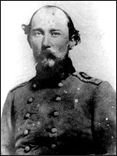
A Poor Start The final advance of Breckinridge’s forces was preceded by Major James De Baun’s partisan rangers. The purpose of these mounted pickets was to ensure that no unexpected obstacles or interference would be encountered as the combat units moved into their final assault positions. At 0300 the horsemen arrived at Ward Creek about three miles east of Baton Rouge. There is no indication that they were expected to proceed any further, however they continued into town on the Greenwell Springs Road. As they neared the Magnolia Cemetery they were challenged by the pickets of the 21st Indiana. Unable to give the proper password to the challenge the militiamen elicited the appropriate response from the vigilant sentries. A volley was fired in their direction. The commander of partisan troopers, Captain Tate, ordered the group back to report the incident. The would-be messengers galloped off to make their report. Unfortunately, they were headed directly at the vanguard of MG Benjamin H. Helm’s brigade in the darkness and fog. The sound of the hoof beats bearing down on them quite naturally alerted the approaching Confederates. Not expecting any friendly forces in their front they suspected that any activity there indicated enemy presence. The cry of “Yankee cavalry” was raised and with it the muskets of the lead elements. When the sound of the horses came within range a volley was fired. The militiamen, thinking that they had run into another Union picket line, returned the fire. The exchange of fire had a devastating effect. Several of the rangers were unhorsed, dead or wounded, and the advancing column suffered two major losses. The brigade commander, Helm, was badly injured when his wounded horse fell on him and two guns of Cobb’s battery were made unserviceable when the teams bolted and overturned the pieces. Also killed in the friendly fire episode was Lieutenant Alexander H. Todd, brother-in –law to Abraham Lincoln. When the mistake was discovered a cease fire was immediately called. On the other side of the road Colonel Thomas B. Smith, afraid that his brigade had added to the fire, asked for a report. One of the two remaining members of Company E, 20th Tennessee, W. E. Brothers jumped up, “his gun still smoking, and promptly replied that he did not think that any man in the 20th had fired a gun.” The situation was settled and the injured Helm was replaced by Colonel Thomas H. Hunt of the 5th Kentucky but any hope of surprising the Union forces was gone.
BG Benjamin Helm
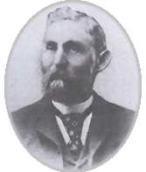
Breckinridge had also dispatched a small detachment to “engage the enemy supposed to be posted with a battery of artillery” near the intersection of the Clinton and Bayou Sara Roads in the northeast corner of the city. To get into position LTC Thomas Shields led his 150 men (Co. E, 30th Louisiana, Co. G, 4th Louisiana , a company of partisan rangers and two guns from Semmes Battery) on a grueling cross country night march. When they arrived at the proper location near dawn they found no Union artillery but circumstances allowed them to pursue another target. When firing was heard to the east (most likely the friendly fire incident between the rangers and Helm’s command) Shields ordered his men forward at the double quick in the dense fog. The Union pickets (Companies B and H, 14th Maine) collapsed after firing a “feeble volley”, leaving much of their equipment behind. Sensing a larger opportunity Shields placed his two guns on the Bayou Sara road and advanced. They were preceded by the Union Officer of the Day Major Holbrook of the 7th Vermont. The major (son of the Governor of Vermont) had been out checking his picket lines when he heard the exchange of gunfire. He galloped into the camp of the 14th Maine and raised the alarm from his sweat covered horse before riding on. The 14th Maine quickly fell out in front of their camp and was taken under oblique fire from the Confederate pieces. Shields would later report that the effectiveness of the fire was greatly reduced by faulty friction primers. According to his report ninety per cent of the devises proved defective. The commander of the Maine men, Colonel Frank Nickerson, changed the facing of the regiment to the north to confront Shield’s men. With trouble in his artillery and the numbers growing steadily against him Shields was forced to withdraw after receiving “volley fire by battalion” within 250 feet of the camp. Once again the poor visibility created by the morning fog led to problems. As they moved into their new position at the junction of the Clinton and Bayou Sara Roads they were fired into by men from Clark’s division moving into town from the east. The fire did not cause any casualties but this ended Shields mission. The bulk of his command was folded into the 22nd Mississippi leaving Shields with just the artillery to command until the end of the battle. Shields’ (killed nearly two years later at Ezra Church) foray accomplished very little of its intended mission, however the movement of the 14th Maine to face the threat posed by his force left their right flank vulnerable to the main Confederate assault.
LTC Thomas Smith
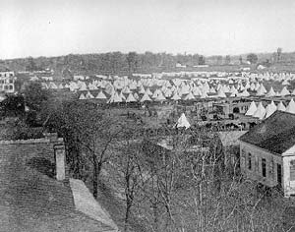
The Ball is Opened When Shields withdrew his tiny force the way was cleared for the main assault to begin. Before the Confederate line could step off into the attack, however, an aggressive Union commander took preemptive action. LTC John Keith of the 21st Indiana ordered the regiment forward at the first sound of action. The Hoosiers took a position along in a row of trees that was fronted by an open field on the eastern outskirts of the city. They were quickly joined by the guns of the 6th Massachusetts Battery. Keith sent a company (Co. A) forward to act as skirmishers and to provide early warning in the dense fog. The probe had not advanced far when they ran into Colonel A. P. Thompson’s Confederate brigade advancing down the south side of Greenwell Springs Road. After a brief exchange of gunfire the skirmishers fell back onto the main line and awaited the attack. As soon as the Confederate line of battle emerged from the fog they were met with a fusillade of musketry and canister. The effect of the fire was to stop the advance in their immediate front as the Confederates threw themselves to the ground. While the units in the field hugged the ground “like lizards between the rows” of the cultivated field the remaining units took advantage of Keith’s exposed position. Ruggles ordered Semmes’ Battery to engage the Federal guns while the left wing of his division maneuvered around the Union right. Keith had anticipated such a move and sent Company C to watch for the left of the enemy line but they were no match for the Confederate strength there. Furthermore the enemy units moving down the northern side of the road were threatening his left. With both flanks being overlapped Keith wisely ordered a retreat. The hasty withdraw left the Massachusetts gunners without support and they barely managed to save the guns from being overrun. The 21st took a new position behind Magnolia Cemetery where they were joined by Clark’s battalion of the 6th Michigan. The respite allowed Ruggles to reorganize his troops and reposition his artillery from the center to the far right of Thompson’s advance along the Greenwell Springs Road. The new position allowed the gunners to support both Thompson’s men and the advance of Clark’s Division north of the road.
Camp of the 21st Indiana at Baton Rouge
On the Union left the 14th Maine had just repelled Shields attack when they were struck in the flank by the full weight of Colonel Hunt’s brigade and the fire of the newly repositioned Confederate artillery. Colonel Nickerson attempted to change the front of the regiment to face the attack under the raking fire of the enemy guns but after a short effort the regiment was ordered to retreat to the area of the orphanage. Here Nickerson regained control and reorganized his men.
On the far right of the Union line Colonel Allen’ s Confederate brigade moved through the cover of thick trees and fell upon the pickets on Keith’s right. The picket line was easily pushed back and the attention of Allen was caught by the battalion of the 6th Michigan, under CPT John Corden, who was supporting two guns of the “Jackass Battery”, commanded by LT James Brown, on the extreme Union right. This was the most thinly defended portion of the Union line but the small group of defenders had chosen their ground wisely. Captain Thomas Bynum of the 9th Louisiana Battalion described the situation this way;
“A regiment (actually Corden’s Battalion) supported the battery and its men were placed behind fences, outhouses, and houses…”
Allen was determined to rid the attack of the threat to its left flank by attacking Corden’s position. To the front of the small Union defensive line lay 300 yards of open field that offered not the slightest hint of cover. Nevertheless, Allen seized the colors of the 9th Louisiana Battalion and led a charge across the field to seize the Federal guns. When the Confederate battle line reached the middle of the field the guns were loaded with canister and joined the Michigan muskets in greeting the Confederate attack. The “scorching fire from a strong line of infantry supporting the artillery” staggered the Confederate line but did not stop them. As the pressure on his line mounted Corden had his men take cover behind a sturdy wooden fence while the Indiana gunners switched to double canister. At a range of 100 yards a devastating blast tore large holes in the Confederate line but still they continued to move forward. At fifty feet the last blast severely wounded Colonel Allen but the battery was taken at the point of the bayonet. With the artillery gone Corden took his men to the rear. The triumphant Confederates raised their banner over the guns. The loss of Allen, however, stole the momentum of the attack and the advance stopped at the battery.
Renewed Assaults For the 21st Indiana and Thompson’s Brigade of Confederates the respite after the first attack was short lived. The Hoosiers had been reinforced by Clark’s battalion of the 6th Michigan and were lying down at the fence of the Magnolia Cemetery awaiting the next move. Thompson’s men moved across the graveyard and into muzzles of the Federal weapons. After a Confederate volley passed over their heads the defenders return fire “was like the blast from the destroying angel.” The Confederates continued their drive despite the losses. One Kentuckian remembered;
“We crossed the cemetery, stopping at the paling fence that enclosed it. We remained here a short time, again on our faces, many of us firing from the baseboard of the fence. Others sat on graves, and fired from the tombstones which protected them.”
The battle here was described by men from both sides as the hottest fight of the day. Keith described the action at the cemetery as an “every man for himself” affair. As the two sides battled on Thompson received word that the fire from his men was striking the men from Clark’s Division as they drove the 14th Maine back. Thompson ordered a cease fire creating a lull during which LTC Keith reevaluated his situation. He saw that Clark’s drive against the 14th Maine, led by the 31st Mississippi, was threatening the guns of the 6th Massachusetts Battery at the orphanage and that he was in the best position to render assistance. He placed the Michigan Battalion and two sections of the 4th Massachusetts Battery in a holding position at the cemetery and moved the 21st by the left flank to a position where he could strike the Confederate attack in the left flank. As the Confederates closed in on the vulnerable guns Colonel Hunt noticed the new threat just as they opened fired and ordered a retreat. During the retreat Hunt was wounded and the command was passed to Colonel Jeptha Edwards who refused it citing exhaustion. Captain John Buckner, of Breckinridge’s staff was given command of the brigade. He managed to reorganize the retreating units at the site of the 14th Maine’s camp.
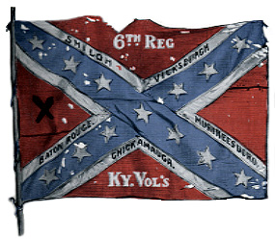
With Keith’s attention turned elsewhere Thompson’s brigade made another effort at the Union center. He urged his men into the reduced Union defense in his front. The revitalized attack pushed the Wolverine’s of Clark’s Michigan Battalion back through the camp of the 21st Indiana. The retreating Federals left behind one gun of the 4th Massachusetts Battery that was claimed by the 6th Kentucky. Thompson then wheeled his men to the right enabling them to catch the 21st Indiana in the flank. To add to their problems the 7th Vermont attempting to aid in the fight fired into the regiment from the rear. The fire from an unexpected direction caused the Indianans to come unraveled .They fell back and Keith related the incident to MG Williams. The Union commander soundly upbraided the Vermonters and ordered Colonel George Roberts, the regimental commander, to have his men fall in on the Hoosiers right. As Roberts was pushing his men forward he was badly wounded and the regiment simply stopped. The captain left in command could not get them to budge. With the battered enemy troops in his front ready to collapse Thompson exhorted the retreating men of Clark’s division to join him in another push. Instead a staffer from Clark’s Division headquarters rode up and informed Thompson that the order was for all troops to move back. Thompson reluctantly obeyed the order. A volunteer party from the newly arrived 30th Massachusetts ventured forward and recovered the gun belonging to the 4th Massachusetts. In their haste to fall back the gun had not even been spiked.
Battle flag of the 6th Kentucky
On the Union right the wounding of Allen had a dramatic effect on the Confederate effort. When CPT Corden realized that he was not being pursued he stopped. Incredibly the Confederates were streaming back the way they had come. Apparently leaderless the Confederates abandoned the ground they had won at so high a cost. Left behind was the battle flag of the 9th Louisiana Battalion, the wounded, and the two captured guns. Corden move his men back to reclaim the guns and found that the retreating enemy had not even bothered to spike them. They were quickly turned and put to work on the fleeing Confederate troops. Lacking adequate strength to pursue the retreating Confederate line Corden resumed his previous position.
Attack, Counterattack and Retreat
As the Confederate forces retreated Union reinforcements arrived in the form of the 30th Massachusetts. The Bay Staters fell in on the right of the 21st/6th Michigan Battalion as the 14th Maine established the left side of the rejuvenated Union line. Williams also used the pause to shift the 9th Connecticut, 4th Wisconsin, and two sections of the 4th Massachusetts Battery eastward into position to form a reserve. As the line moved forward to reclaim the lost ground they met stiff resistance from the 35th Alabama and 6th Kentucky Regiments. Colonel Thompson led his men forward and was badly wounded .The feisty Keith was wounded and was carried from the field. The two sides battled at close range for nearly an hour without making progress. Williams attempting to rally the men went to the front and announced that he would lead them. He urged the Hoosiers to reclaim their camp and led them forward. He had not gone far when he was shot and killed by a bullet to the heart. Command of the Union forces fell to Colonel Cahill of the 9th Connecticut. The new commander ordered all Federal units to retire slowly to the river. As the Union troops moved back to the reserve line formed by the 9th Connecticut and 4th Wisconsin the aggressive Confederates attempted to follow. Corporal Peabody of the 4th Massachusetts Battery described the scene;
“The enemy seeing this backward move, sprang from cover, but all the batteries opening, he saw that we still intended to fight, and fell back again.”
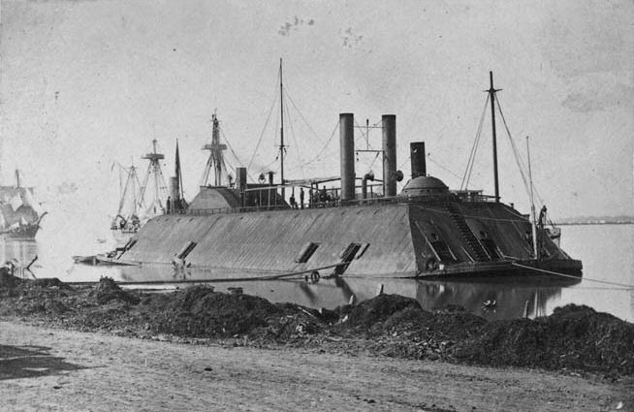
It is not clearly understood that the retreat of the Union forces was the intended action, although Cahill states that he had discussed it with Williams before his death, the result did have a positive influence on the defense of the city. The sun had now burned off the morning fog and the separation of the two forces created by the retreat allowed the Union ships to add the weight of their fire to the fight.
The crews of the Union ships had been standing by their guns waiting for the opportunity to contribute to the battle. The Essex and the Sumter were positioned above the city and had clear fields of fire over the Bayou Gross. The two ships opened on the Confederate left flank. The powerful 11” guns of the Essex proved particularly demoralizing to the battered Confederates.
USS Essex
On the right the confused situation caused Lt Ransom to withhold the fire of his two ships stating;
“The Kineo and Katahdin were placed immediately in a position previously indicated to me by General Williams, to protect his right flank, but his lines were so much extended, and so completely covered the enemy approach, that our guns could not be made available with safety to our troops…”
As the distance between the two forces on the right became more pronounced the two ships joined in the barrage. The position of the two vessels required them to fire over the town but Ransom had sent an officer into the tower of the State House to direct their fire by “prearranged signals.” The adjusted fire beat down unmercifully on the Confederate ranks yet Breckinridge held his position. The troops were exhausted, hungry, and desperate for water under the brutal August sun but they waited for the chance to renew the struggle. If the Arkansas could move the Union fleet away they were confident that they would be victorious. There was nothing to do but await the resolution of the fight at the river.
Breckinridge maintained his position into the afternoon waiting for the Southern ironclad. Finally a courier arrived with a message announcing that the ship’s engines had failed and she would be unable to assist. A dismayed Breckinridge had little choice but to give up the hope of capturing the city. He wrote of his decision to call off the attempt to reclaim the city;
“The enemy had several batteries commanding the approaches to the arsenal and barracks and the gunboats had already reopened upon us with a direct fire. Under the circumstances, although the troops showed the utmost indifference to danger and death, and were reluctant to retire, I did not deem it prudent to pursue the victory further.”
The battle for Baton Rouge was over. The swirling, confused, back and forth affair had claimed an estimated 835 casualties. Five hours of deadly close quarters combat left the situation at Baton Rouge unchanged.
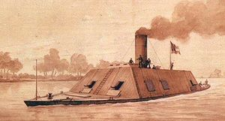
Death of the Arkansas
Despite the absence of its commander, LT Isaac Brown, and the chief engineer the damaged Arkansas was ordered south to cooperate with Breckinridge’s effort at Baton Rouge. In order to make it to the city by the August 5th date set by Van Dorn the ship would have to make steady headway in the thirty hours before the deadline. The strain proved too much for the unreliable engines of the ironclad. Several stops were needed to make repairs. During one of these halts LT Gift was sent ashore near Port Gibson to gather information about what waited for them at their destination. In addition to information regarding the size of the Union fleet off Baton Rouge the acting commander, LT H. K. Stevens, also learned that Breckinridge was in place waiting to launch his attack at the prescribed time. There was no time to spare. The ship had to be pushed if they were to arrive in time to render the expected assistance.
CSS Arkansas
As Breckinridge’s troops made their final approach to the city the ship moved to within fifteen miles of the city. Suddenly the starboard engine broke down and the ship veered into the shore. Stevens had the ship tied off while the acting engineer, Eugene Brown, worked frantically with his crew to make repairs. At about 0800 Brown reported that the engine had been repaired and they could make way. The ironclad traveled another five miles when just as they caught sight of the Federal fleet the starboard engine failed again. As before the ship veered hard right and got hung up on submerged tree stumps near the shore. Once again Brown’s men threw themselves into the repair of the balky engine. As the battle raged for the city the crew watched helplessly, unable to move. Fortunately the Union vessels became involved in the fight and paid little attention to the stricken vessel. When the repairs were complete Stevens found he could not free the vessel without shedding some of the heavy iron that had been laid on the deck to protect from plunging fire. At 1700, well after the battle for Baton Rouge had been given up by Breckinridge, the ship finally broke free from the underwater snag. The overworked Brown reported to Stevens that he had little confidence that the engines would remain running and suggested that they move upstream to put on coal and test the engine away from the guns of the hostile fleet downstream. Stevens agreed and turned the ship upstream.
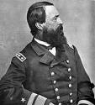
The strain of moving against the current again proved too much for the machinery. After travelling only 500 yards the pin holding the starboard connecting rod in place snapped. One of Brown’s repairmen, also a blacksmith, was put ashore where a forge was set up and a new pin fabricated. The repairmen worked through the night to put the engine back into working order. As the sun rose on the 6th Brown again informed Stevens that repairs were complete but he doubted the reliability of the engines. As Stevens pondered the next course of action the Essex appeared and a duel between the two vessels seemed inevitable. Stevens called his gunners to their stations and the Arkansas moved slowly toward the Union ironclad. As Brown had predicted the engines again failed them at this critical moment. First the port connecting rod broke sending the vessel directly left and then the starboard engine stopped as well. The boat drifted helplessly as the Essex opened fire from extreme range. LT Charles Read returned the fire with one of the 32 lbers in the stern but quit the effort when the range proved too great to make either ships fire effective. As the ship settled against the bank of the river Brown again attempted to make repairs but this time there was nothing to be done. The engines were beyond his ability to repair and he sadly notified Stevens that there was no hope.
Commodore W. D. Porter
Stevens realized that there was no use in risking the lives of the crew in a one sided fight and that the ship would have to be scuttled to prevent it from falling into the hands of the enemy. The crew was ordered off the stricken ship and marched inland to prevent capture by a Union landing party that was spotted being put ashore downstream. Stevens and six others remained aboard to complete the destruction of the warship. As the men went about their sad task Stevens went into the engine compartment to ensure the complete disabling of the machinery. A grenade (most likely a Molotov cocktail type mixture) prematurely exploded badly burning Stevens’ hands. The remaining members of the scuttling party finished the work and helped the wounded Stevens from the ship. The approaching Federal ships gave the burning vessel plenty of room realizing that the guns were probably left loaded to discharge as the fire reach them and that when the magazine ignited there would be a tremendous explosion. The mighty ship drifted downstream discharging the preloaded guns one by one until finally at 1300 she disappeared in a climatic blast. The feared ship’s career had lasted less than a month. LT Read described the escape of the scuttling crew this way;
“We travelled through Louisiana partly on foot, horseback, and in wagons, the planters and their wives and daughters receiving us all along our route with utmost kindness.”
The party eventually arrived at Camp Moore and from there took a train to Jackson, Mississippi arriving on 9 August, 1862.
Aftermath
Breckinridge took his battered forces away from the city under the protection of a covering force that included the 7th Kentucky and Semmes Battery. The first priority was the search for water. The stagnant water of Ward Creek proved unusable but the locals guided the men to cisterns of potable water on the outskirts of the city. As the parched men satisfied their thirst Breckinridge sent Major James De Baun into town under a flag of truce. Breckinridge requested that he be allowed to enter the city to bury his dead but was refused by Colonel Cahill. Casualties for this contest were difficult to discern, particularly for the Confederate side. Wounded that were taken from the field were deposited all along the retreat route. The best estimate indicates the Confederate losses were 84 killed, 315 wounded, and 57 missing. The Union forces suffered 84 killed, 266 wounded, and 33 missing. Among the missing was 8 year old Edward Black, drummer boy for the 21st Indiana. Thought to be the youngest soldier to fight in the Civil War, Black was taken captive. He was exchanged in September of 1862 and reenlisted into the 21st Indiana. He survived the war but died at the age of 17.
The Union forces did not pursue the retreating Confederates instead they immediately started to dig in under their newly arrived commander, Colonel Halbert Paine of the 4th Wisconsin. Paine had been placed under arrest by Williams for a minor offense and sent to New Orleans. When the word of Williams’ death reached Butler he wasted no time returning Paine to the city to get control of the situation. Breckinridge received orders from Van Dorn to take the remainder of his force to fortify Port Hudson. Van Dorn also sent Bowen’s Brigade (plus the 12th Louisiana) from Vicksburg to reinforce Breckinridge. Bowen maintained a position near the Comite River while Breckinridge and the two badly damaged brigades staggered into Port Hudson. This Confederate force lurking nearby led Paine to believe that another attack was pending. Included in the preparations for defending against the expected attack was the destruction of about a third of the town to clear fields of fire for the gunboats on the river. For a week the town was looted despite the protestations of Colonel James W. McMillan of the 21st Indiana. The officers would not or could not control their men. Finally Butler, who had been determined to hold the city, changed his mind and ordered the entire city burned to the ground before moving the troops back to New Orleans. A strong appeal by engineer office, LT Godfrey Weitzel, sent to the city with Paine by Butler to supervise the construction of defenses, citing the humanitarian purposes of the orphanage and insane asylum convinced Butler to rescind the order on 19 August. The Federal troops boarded a parade of transport ships sent up from New Orleans on 21 August after completely gutting the city.
In a sad note the Lewis Whiteman, a captured steamer being used to evacuate wounded and prisoners from the scene was sunk after it collided with the Oneida while on the way to New Orleans. The commander of the Oneida, LT G. H. Preble, believed the collision to be a deliberate act. In his report of the incident Preble noted that the captain of the Whiteman had four sons in Confederate service and had stated he would be so to if he was younger. He substantiated his report with a statement from the engineer aboard the Whiteman that the ship had built 120 lbs of steam and had plenty of clearance to avoid the Oneida in the bright moonlight. The Oneida survived the collision while the Whiteman went down taking 40 of the wounded and prisoners with her.
Although they had failed to gain their objective at Baton Rouge, Breckinridge gained a more valuable prize in retreat. Under the guidance of Confederate engineer, Captain James Nocquet, Port Hudson was made into a formable fortress. The presence there allowed the Confederates to control a significant portion of the river. Food and supplies from the Trans-Mississippi could still get to the Confederate armies as long as they held this position.
Butler vs. the 7th Vermont
In a supplemental congratulatory message on 25 August (General order No. 62 ½) MG Butler continued to heap praise on the defenders of Baton Rouge with one exception. The 7th Vermont was excluded from the previous message for the following offenses;
- The regiment refused to march to the aid of the 21st Indiana.
- The regiment fired into the back of the 21st Indiana.
- The regiment abandoned their colors which were saved by another unit (4th Massachusetts Battery).
As a penalty for these perceived misdeeds the regiment was forbidden to include the words “Baton Rouge” on their colors as the other units proudly did. Furthermore the regiment was forbidden to carry their colors until they proved themselves in battle. An additional insult was added when Butler wrote that the deceased Colonel Roberts “was worthy of a better disciplined regiment” than the one that broke “in confusion” during the fight at Baton Rouge.

In the Civil War atmosphere of honor and dedication to ones flag and regiment no such affront could go unchallenged. With Roberts gone the task of taking up the defense of the 7th Vermont fell to the new commander, Major W. C. Holbrook. Holbrook filed a request to MG Butler for a court of inquiry to “investigate and report upon the battle of Baton Rouge and the part taken in that engagement by my regiment”. In his application for redress Holbrook regretted “exceedingly” the need to file a “scrutiny of a victory” but felt “impelled” to do so. The request was indorsed up the chain by BG N. A. M. Dudley with no comment but BG J. W. Phelps, a native Vermonter, wrote that he “regretted that a regiment in this quarter should be compelled to defend itself against unmerited dishonor from its commanding general”. A smug Butler forwarded the “somewhat anomalous application” to Henry Halleck noting that “if consistent with the rules of the service to inquire into the resume by the commanding general of the events of an action, I should be glad to have it done.”

Halleck threw the hot potato back into Butler’s lap stating that “no officer can at this time be sent to New Orleans to constitute such a court.” Halleck’s action was probably prompted by letters from Frederick Holbrook (Major Holbrook’s father) the Governor of Vermont. When the charges against the 7th Vermont were made known to him he immediately used contacts in Washington to press the issue. When things did not seem to be moving fast enough he wrote Secretary of Stanton demanding “nothing short of an entirely impartial court of inquiry” would “satisfy our people.” Butler had to buckle to the political pressure to appease the governor. On October 23, 1862 a court of officers selected by Major Holbrook to ensure impartiality was convened. Selected to sit on the board were Colonel H. C. Deming (President, 12th Connecticut), Colonel J. W. Turner and LTC A. B. Farr (26th Massachusetts). Lieutenant W. L. G. Greene (2nd Louisiana), “a gentleman of considerable legal experience” was appointed to act as recorder by MG Butler. Not surprisingly given the political nature of the issue the board redeemed the regiment.

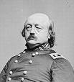
In the report of the proceedings the board found that with Roberts dead, Holbrook on other duty and the next senior man on a mission ordered by Roberts the command had fallen to a captain. The board gave the captain credit for acting “creditably in a trying position”. As to charges that the regiment had fired into the 21st Indiana the board found that given the fog and smoke that encased the field and the testimony of Captain Grimsley of the 21st that the Hoosiers may have run into the fire that was already in progress the 7th Vermont could not be held responsible. The charge by Captain Manning of the 4th Massachusetts Battery that their colors had been abandoned and recovered by his men was thrown out when it was discovered that the flags in the possession of Manning were not in fact the regimental colors but “were two markers of the form in common use and one small United States flag”. The Vermonters color guard had retained possession of the actual regimental colors throughout the engagement. Finally it was found that the regiment was not given any orders which they disobeyed.
MG Benjamin Butler
Butler was forced to return the colors to the regiment but in a face saving move did not remove the restriction against placing the words “Baton Rouge” on them. The matter was resolved and the 7th Vermont for the most part vindicated. They would be shipped off to duty in Florida shortly thereafter.
Conclusion and Assessment
The Battle of Baton Rouge was a swirling melee. The darkness, fog, noise, and close combat stretched the limits of command and control for an army of this time. Well established plans fell apart almost immediately in the confusion. The initial Confederate attack was intended to be a collective effort by all four brigades. Allen’s brigade, however, became preoccupied by Corden’s isolated party on the far Confederate left. Although they gained their initial objective their success could not be maintained after the loss of Allen. When Allen’s men were punished and beaten back by the much smaller enemy force a significant manpower loss was felt by the main Confederate effort. When Colonel Breaux was unable to rally the remnants of Allen’s brigade, Thompson’s men took on the whole burden of the fight south of Greenwell Springs Road alone. The piecemeal, uncoordinated attacks by the three active Confederate brigades that followed did not allow them to place the full weight of their combat power on the Union defense at the same time. The role that the failure on the Confederate left played in the ultimate defeat was not missed by the senior commanders. At the death of Allen, the leadership failed to rally the troops there. The scrutiny of his handling of the situation there caused Colonel Breaux to resign his commission and go back to New Orleans where he took the Oath of Allegiance to the Union. The next senior leader LTC Hunter was brought up on charges of cowardice.
Another problem faced by the Confederate commanders was a lack of artillery support. The early loss of two guns by Cobb’s battery placed them in an even greater artillery deficit. The burden of support for the main effort at Greenwell Springs Road fell on Semmes’ Battery. Although Ruggles displayed a fine sense of tactical necessity in the movement of these guns there was simply not enough artillery to go around.
The early deployment of the 21st Indiana by Keith set the tone for the battle from the very outset. This would be a fight for every inch. Williams never brought all his units into the fight. As a result the bulk of the battle was fought almost exclusively by three regiments (21st Indiana, 14th Maine, and 6th Michigan) and the vitally important artillery. The casualty report gives clear evidence of the primary role played by these units. Fortunately for Williams the late introduction of reinforcements and the naval gunfire proved decisive.
There is debate over who won the Battle of Baton Rouge. In regards to objectives gained or lost the tactical decision would have to go the Union forces. Breckinridge’s goal was to capture the city but he did not. Although William’s defense was strained to the last it managed to accomplish its goal; the city was saved. Strategic victory would certainly be a different story. While the Federals managed to hang on to Baton Rouge it offered them no real benefit. Tactically defeated Breckinridge won the strategic prize in retreat; Port Hudson.
In the end the battle for Baton Rouge should never have been fought at all. From the very beginning Van Dorn’s subordinates disagreed with the campaign. Breckinridge and Clark both argued that the city even if gained could not be defended. They agreed with Sterling Price that the object of the most interest to the Confederate cause was Port Hudson. The occupation of Baton Rouge held no real value to the Union cause either. They should have seen the importance of Port Hudson and beaten the Confederates to the punch there. Realizing the drain that Baton Rouge put on their resources the city was abandoned. Both sides could have had what they ultimately ended up with without a bloodletting.

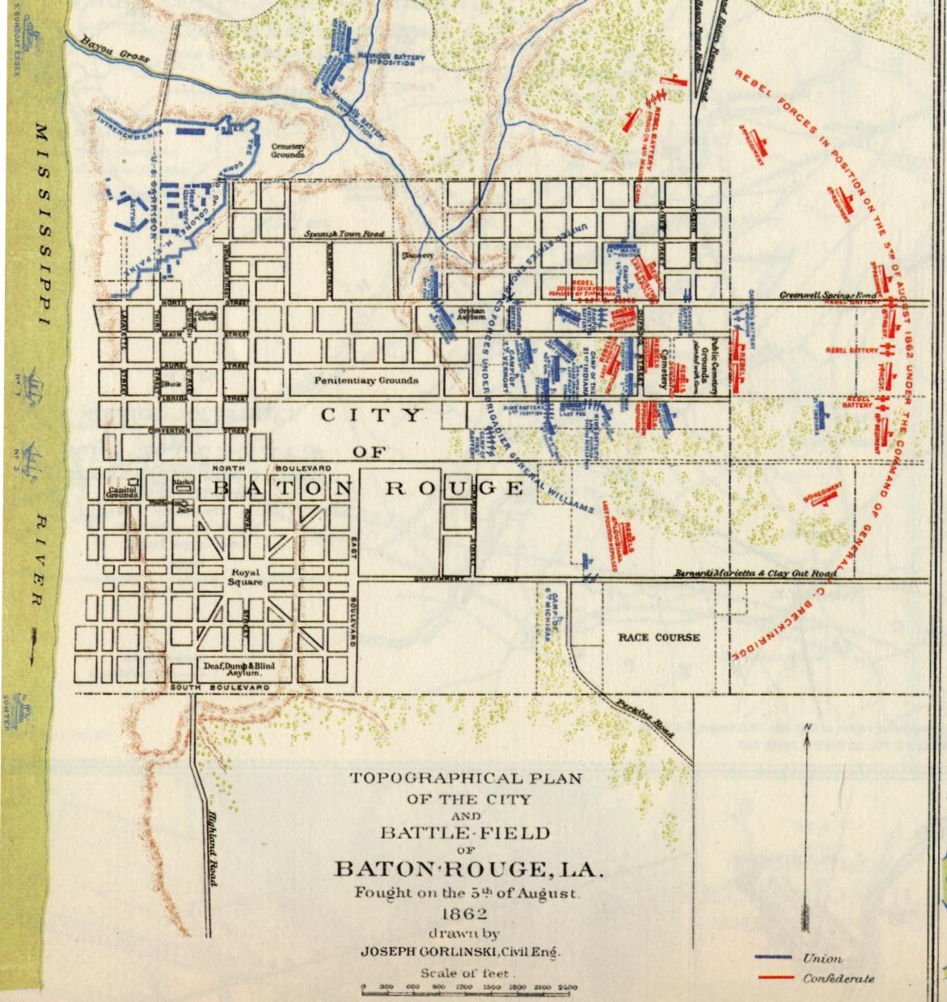
Battle of Baton Rouge – Order of Battle
Confederate BG John C. Breckinridge
BG Charles Clark’s Division BG Benjamin Helm’s Brigade 4th Kentucky, 5th Kentucky , 31st Mississippi, 31st Alabama, 4th Alabama Battalion, Hudson’s Battery Colonel Thomas B. Smith’s Brigade 19th Tennessee, 20th Tennessee, 28th Tennessee, 45th Tennessee, 22nd Mississippi, 15th Mississippi (Reserve)
BG Daniel Ruggles Division Colonel Albert P. Thompson’s Brigade 35th Alabama, 3rd Kentucky, 6th Kentucky, 7th Kentucky, Hubbard’s Sharpshooters Colonel Henry W. Allen’s Brigade 4th Louisiana, 30th Louisiana, 9th Louisiana Battalion, 39th Mississippi (Co. I), 9th Partisan Rangers, Semmes’ Battery
CSS Arkansas
Union BG Thomas Williams 6th Michigan, 30th Massachusetts, 7th Vermont, 21st Indiana, 4th Wisconsin, 9th Connecticut, 14th Maine, 2nd Massachusetts Battery, 4th Massachusetts Battery, 6th Massachusetts Battery
USS Essex, USS Katahdin, USS Kineo, USS Sumter

BIBLIOGRAPHY Official Records of the Union and Confederate Armies in the War of Rebellion Volume XV Allen, H. W.; Bean Sydney A.; Bowman, J. H.; Breaux, Gustavus A.; Breckinridge, John C.; Buckner, John A.; Butler, Benjamin P.; Bynum, Thomas; Cahill, Thomas W.; Carruth, William W.; Clarke, Charles E.; Cofer, M. H.; Crossland, Edward; Dudley, N. A. M.; Edwards, Jeptha; FitzGibbons, Richard; Fullam, Volney S.; Goodwin, Edward; Grimsley, James; Hunter, S. E.; Manning, Charles H.; Millett, John H.; Nickerson, Frank S.; Robertson, J. W.; Ruggles, Daniel; Semmes, O. J.; Shields, T.; Smith, T. B.; Snodgrass, John; Topp, H. E.; Trull, George G.; Weitzel, Godfrey; Whittemore, Horace O.; Wickliffe, J. C.; Van Dorn, Earl; Williams, Thomas Official Records of the Union and Confederate Navies in the War of Rebellion Vol. 19 Brown, I. N.; Cahill, T. W.; De Baun, J.; Farragut, D. G.; Porter, W. D.; Ransom, G. M.; Read, Lt; Roe, F. A.; Ruggles, D.; Wilson, J. A.; Van Dorn, E.; Preble, G. H.; Edmundson, A. H.; Thompson, M. J. Books The Battle of Baton Rouge, Thomas H. Richey Confederate Military History of Louisiana, John Dimitry The Civil War in Louisiana, John D. Winters The Darkest Days of the War – The Battles of Iuka &Corinth, Peter Cozzens The Battle of Baton Rouge – 1862, William Spedale Online Books History of the 9th Regiment of Connecticut Volunteers, Thomas H. Murray, 1903 History of the 2nd Massachusetts Battery, Caroline E. Whitcomb, 1912 History of the 20th Tennessee Regiment Volunteer Infantry, William J. McMurray, 1904 History of the First Kentucky Brigade, Edwin P. Thompson, 1868 ARTICLES Battle of Baton Rouge, Harper’s Weekly, 6 September 1862 Battle of Baton Rouge – August 5th, 1862, Christopher G. Pena The Battle of Baton Rouge, Edwin C. Bearss, The Journal of the Louisiana Historical Association, Vol. III, No. 2, Spring 1962 The Confederate Gun-boat “Arkansas”, Captain Isaac N. Brown CSN, Battles and Leaders of the Civil War, Vol. III Military Operations in Louisiana, LTC Richard B. Irwin, Battles and Leaders of the Civil War, Vol. III Internet Resources http://www.historyofwar.org/articles/battles_baton_rouge.html http://www.nps.gov/hps/abpp/battles/la003.htm http://www.maine.gov/sos/arc/archives/military/civilwar/14meinf.htm http://6thkentuckyinfantry.org/6th-Kentucky-Infantry.html http://www.mississippiscv.org/MS_Units/22nd_MS_INF.htm
Numerous websites used to confirm unit histories, biographical details and other information.

