Milliken’s Bend
to the
Big Black

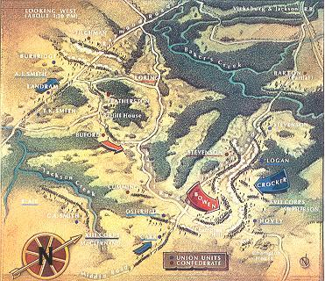
SFC Daniel O’Connell
Introduction – 55 Days that Doomed the Confederacy
There are those that believe that the American Civil War was fought in the east and won in the west. To the adherents of that view control of the Mississippi River was every bit as important to the Confederate cause as the defense of Richmond. The famous Anaconda Plan took this into consideration as the Union war planners were devising a means to defeat the South. The plan, simply stated, called for the division of the Confederacy at the Mississippi coupled with a blockade of the coast which would gradually create an untenable situation for the support of the Southern armies and the civilian population that supported them. If this be true, which certainly proved to be the case, there is no more important time in the history of the war than the period between 29 March 1863 and 22 May 1863 in Louisiana and Mississippi. These fifty-five days contained the events that gave the Union the ability to encircle the keystone city in the west, Vicksburg, and gain complete control of the Mississippi River.
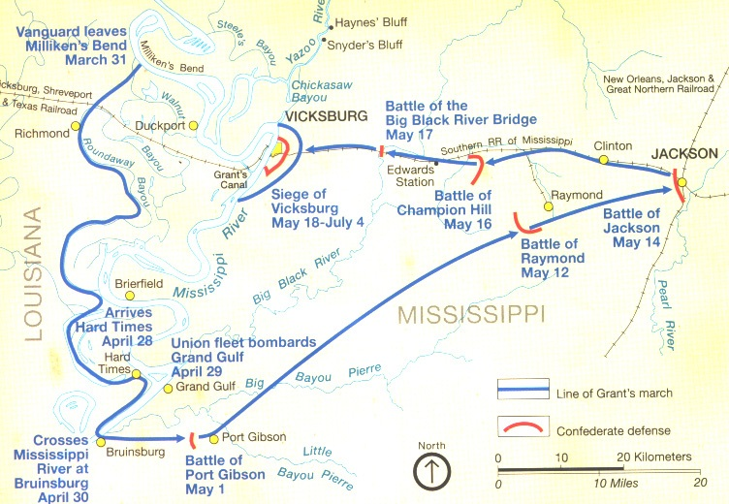
This short period saw mass troop movements over forbidding terrain, masterpieces of field engineering, the largest amphibious operation in United States military history until 1942, textbook inter-service cooperation, a diversionary cavalry raid, a major supporting campaign, five important battles that are rarely ever spoken of by Civil War historians, countless skirmishes, and the story of two commanders who took opposite routes to victory and defeat. One who insulted military convention with his daring, innovation and tenacity while the other remained unexplainably idle while his chances for victory passed him by.
The dramatic events of this critical period began innocently enough on the evening of March 29th. MG John A. McClernand’s XIII Corps were assigned the task of determining if Vicksburg might be bypassed on the west bank of the Mississippi River to a point where troops could be loaded for a trip across the river to attack the city from the south. McClernand reported that his corps “was in a favorable position to test this question.” The next day a specially selected group began the march south from Milliken’s Bend.
On to Richmond! (Louisiana)
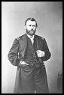
Failure of several initiatives to bypass the Vicksburg defense and the impracticality of assaulting the fortress city from the north prompted MG Ulysses S. Grant to form another plan. The two remaining alternatives were to return to Tennessee and attempt another land approach or move south down the west bank of the Mississippi and then across the river to attack the city from a new direction. Having failed once at the first alternative Grant had no wish to revisit that scenario so he boldly opted for the second option. He understood that the success of this plan was entirely linked with cooperation of the naval forces in the area. After being assured by Rear Admiral David Porter that his river squadron would be at his disposal Grant initiated the operation that would eventually move three army corps across the formable natural barrier formed by the Mississippi River. Despite an exceptionally stormy relationship with its commander, MG McClernand, Grant ordered XIII Corps to lead the way south.
McClernand selected the 69th Indiana Infantry, under the command of Colonel Thomas Bennett, as the vanguard of his movement. In addition to his own men Bennett’s command was supplemented by “detachments of cavalry and pioneers.” The cavalry troopers were supplied by the 2nd Illinois Cavalry and the engineer support by Captain Patterson’s Independent Company of Kentucky Engineers and Mechanics. The Kentuckians were outfitted with a small pontoon train that slowed the rate of advance considerably but proved to be quite useful in the inundated landscape.
Ulysses S. Grant
The soldiers of the 69th Indiana were delighted at the prospect of leaving their mud soaked and disease ridden camps. Service at the “low lands of sorrow” was filled with fatigue duty trying to maintain their precious, but tenuous, toehold on semi-dry soil or digging in the ill-fated canal project across the peninsular. On the morning of March 30th the advance left camp and began the march south. Their mission was to “examine the practicability of a road or connection between Richmond, La. and New Carthage, La. on the Mississippi.”
The first thirty-two miles of the venture proved uneventful. At 1600 on the 31st as they approached Richmond, county seat for Madison County, they were fired upon by a small party of Confederate cavalry. These pickets represented a portion of the only known enemy troops in the area, Major Isaac F. Harrison’s 15th Louisiana Cavalry Battalion. Total strength of this unit was estimated by division commander, BG Osterhaus, at “four companies, about 60 men each, and one battery of six smooth-bore 6-pounder guns.” The small group at Richmond was quickly driven back by Union attackers who paddled across the bayou in the pontoon boats using the butts of their weapons as oars. The retreating enemy was then chased from town by a small group of cavalry that swam their horses across the bayou. Of the seven Confederates that were wounded four were left to become captives.
Possession of Richmond proved to be a brief but pleasant interlude for the Federal force.
In town they found plenty to eat and dry accommodations in the courthouse. The infantrymen remained there throughout the first day of April while the mounted men searched for a dry route toward New Carthage. On the 2nd the 69th moved to a plantation three miles south and camped near the slave quarters. Here they were treated to a “genuine plantation hoe-down” led by a slave elder grinding away at a hand organ accompanied by “a violin, banjo and a pair of bones” much to the enjoyment of the soldiers and the slaves alike. After a bridge over the bayou was constructed the march to New Carthage continued.
Cruise of The Opossum
The expedition from Richmond to New Carthage was reinforced by detachments from the 3rd Illinois Cavalry, 6th Missouri Cavalry, the 49th Indiana Infantry, and four additional artillery pieces. They departed at sunrise on the 4th and by 0900 were at Holmes Plantation. Enemy forces departed the area on the approach of the superior force. They were seen observing the Federal movements but always from a safe distance.
About two miles from New Carthage at the intersection of Roundway Bayou and Bayou Vidal the road disappeared. The only way into town was by boat. Naturally the Confederate troops in the area had removed nearly all the watercraft to the far side of the flood plain. Several small craft were scoured from the surrounding area but a larger vessel was required to carry the horses and artillery across the flooded approach. On the 5th a detail of 20 men from the 3rd Illinois Cavalry was sent in search of a flat boat said to be tied on the near side 8 miles downstream. This intelligence came from a group of five black men who came into camp seeking refuge. They gleefully joined the troopers to act as guides and to crew the boat on the return trip.
The flatboat was located on Bayou Vidal and the volunteer crew placed on board to guide the boat back to Smith’s Plantation. The voyage was challenged “by about 50 of the enemy’s cavalry, on the east side of the stream.” The resulting fire fight did little to impede the progress of the boat and claimed 1 Confederate trooper killed and another wounded. The boat arrived safely. Osterhaus realized that any passage of the bayou would be opposed so he called on Captain Patterson’s engineers “to arrange the flat-boat so as to give protection against musketry fire, and to receive one light gun and a requisite infantry force.” The engineers spent the day transforming the nondescript craft from flat boat into a “gunboat.”
Private John C. Kitselman, recalling the adventure for the 1894 69th Indiana Regimental reunion, described the craft this way;

“…set posts firmly along the sides, then procured two-inch planks from the other flatboats sufficient to wall up the sides to a height of six feet, cut loop-holes for our rifles, placed cotton bales in the bow and stern…mounted a small mountain howitzer in the bow…”

The “gunboat” was lacking only a name and a crew before it could set sail. Osterhaus settled the dispute on the vessel’s name by scrawling The Opossum across the side with a piece of charcoal. Manning the vessel proved no more difficult. A call for volunteers brought a mad rush to get aboard. About 20 lucky soldiers set sail on the morning of the 6th.
The ungainly craft was propelled and maneuvered by a pole man in each corner. Occasionally the crew would have to go overboard to free the boat from an underwater obstruction but eventually they found their way to the eastern shore. An attempted landing was thwarted by six Confederate pickets who fired on the boat. Kitselman remembered that “we would have resented this insult by blowing them out of existence with our howitzer, but at the moment the business end of The Opossum pointed..” in the wrong direction. By the time the boat was brought about the enemy pickets had fled. The landing point was secured and troops began shuttling across the bayou. The successful cruise of The Opossum gave Osterhaus possession of the only 20 acres of dry ground in the area. He immediately advanced two companies of infantry (one from the 69th and one from the 49th) to the James Plantation and drove the Confederates away after an hour long skirmish. The plantation and its grounds afforded a place to concentrate the follow on forces for the final approach to New Carthage.
Bowen Responds
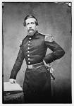
The Confederate commander at Grand Gulf, twenty-five miles south of Vicksburg, was paying close attention to the Federal activities across the river. BG John S. Bowen clearly understood the threat that the Union movements represented not only to his position but the overall Confederate defense of the area. To gain time for an appraisal of the situation and to formulate an appropriate response he sent two regiments of Missouri Infantry (1st and 2nd) from Colonel Francis Cockrell’s brigade across the river to Hard Times, Louisiana to slow the Federal advance.
Cockrell immediately started to probe forward in search of the Federal advance. On April 8th he made contact with the Federals at the Ione Plantation. He sent Bowen detailed accounts of the Union movements but became impatient for a fight and targeted the Federal outpost at Dunbar’s Plantation. In the darkness of the morning of April 15th the 1st Missouri advanced across the waist deep water of Mill Bayou and approached the plantation near dawn. Drowsy Federal pickets quickly gave way and the remainder of the 2nd Illinois Cavalry was caught completely by surprise and conducted a disorganized withdraw. With the Union troopers gone the Missourians rushed to the main house and conducted a room by room search. Several men were captured including the chaplain who was caught while entertaining a “young, full grown, athletic” slave woman much to the amusement of his Confederate captors.
BG John S. Bowen
Bowen reported to Pemberton that;

“Colonel Cockrell had a skirmish today, killing 2, wounding 3, and capturing 4 of the enemy, releasing a major and a number of women and children held in their lines, also retaking over 100 negroes, captured 5 or 6 horses and equipage. No loss on our side.”

Cockrell’s success could not be maintained in the face of the growing Union reinforcements rushing to the area. When the Federals gathered themselves to take back the plantation Cockrell had no choice but to fall back the way he had come. Major Harrison and another portion of the Confederate troops were waiting for Cockrell to advance after the Dunbar Plantation exploit but had to cancel an attempt on the Ione Plantation when they failed to appear.
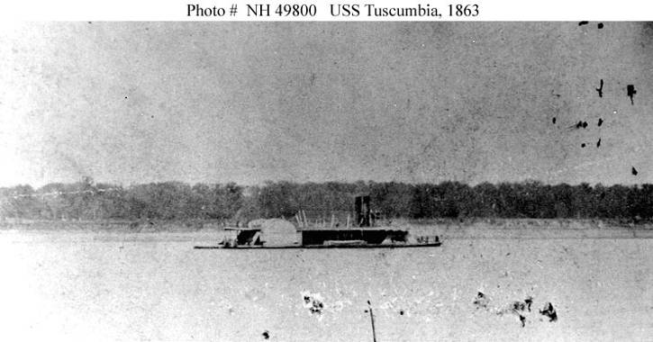
The feisty Cockrell wanted another crack at the Union troops but the passage of the batteries by a portion of Porter’s Mississippi Squadron on the night of the 16th ruined any such plans. Without naval support to protect the boats needed to ferry men across the river from the new Union threat Bowen, fearful that Cockrell’s men would become trapped on the west bank of the river, ordered them to return. The Confederate troops were first pushed away from the river when they were shelled by the Tuscumbia on the 17th. They sought refuge near Lake Saint Joseph until the 29th when, with the Federal fleet occupied with the attempt at Grand Gulf, they were ferried back to the Mississippi side of the river. With the only substantial enemy force retarding his progress gone Grant was now free to operate with only the threat of cavalry harassment to impede him. Grant met with McClernand and determined that the time had come to move McPherson’s XVII Corps up as well. To facilitate this move McClernand’s Corps was moved forward to Pointe Clear. These actions required nearly full time repair of the existing roads and additional construction to support the movement of men and supplies. Grant wasted no time putting his engineers to work improving the roads in the swampy low lands of Louisiana.
Engineers in Action
While the Civil War in general gave rise to the engineer soldiers status no other action can give as much testimony to the importance of the engineers as an independent branch of the Army than the Vicksburg Campaign. At the beginning of the war the need for specialty troops was virtually ignored. Only one small company of Engineers troops existed in the entire United States Army. The demands of continental sized operations soon made the need for these types of troops clear. The bayous, rivers, and lowlands of Louisiana and Mississippi would test these soldiers like no other place. The hard working engineer troops, pioneers, and detailed labor of Grant’s Army of the Tennessee proved more than equal to the task.
Without armed opposition the Union builders were free to work. And the amount of work they produced is astonishing given the conditions. Grant’s engineer force consisted of 2nd Battalion of the 1st Missouri Engineers (Companies A, D, F, and I) the Independent Company of Kentucky Engineers and Miners, and Company I , 35th Missouri, detailed as the pontoon company.
In late March the 1st Missouri Engineers blew a hole in the western levee of the Mississippi River to flood the countryside in an effort to link the bayous together for a water passage to bypass Vicksburg. After eight days of labor using a cumbersome underwater saw apparatus to cut about 700 trees a day a two mile section had been cleared. Unfortunately the plan had to be abandoned when the resulting water levels proved too low to support even small vessels.
The flooded terrain they had created now had to be conquered in a different fashion. The soggy landscape had to be bridged and roads built to allow passage of three federal Corps. In the period of 30 March to 24 April the engineer tasks included:
- A 200 foot bridge constructed from barn timbers over Roundway Bayou.
- A corduroy road, 20 feet wide from Milliken’s Bend to Richmond, Louisiana.
- A drain to draw water away from the vital road network constructed by companies A, D, and F of the 1st Missouri.
- Clearing of Roundway Bayou by I Company of the 1st Missouri
- A dam built to retain water in Roundway Bayou built by 1st Missouri and 127th Illinois.
When the flooding at New Carthage made the original plan of consolidation there untenable a new location for boarding the troops onto the barges for the trip across the Mississippi had to be found. On April 24th an investigation of a route to Perkin’s Plantation found several breaks in the levee road. In four days the Kentucky Engineers, 34th Indiana and pioneer troops from the 12th Division built four bridges totaling more than 1200 feet and two miles of connecting road were cut through the trees.
The road from Milliken’s’ Bend was now nearly forty miles long and required constant maintenance. When Grant decided on Hard Times and then Deshroon’s Landing as the embarkation point another 23 miles were added to the already lengthy route. From Perkin’s Plantation to Hard Times three more bridges were built. Four more, between 80 and 120 feet in length, were built between Hard Times and Deshroon’s Landing. Nearly all required excavation to level the exit and entry points.
When this route proved too long to effectively supply the planned movement still more work needed to be done. Grant ordered a road built from Young’s Point to the western levee opposite Warrenton to shorten the line. The road was started on May 9th by Captain William Jenney and one regiment of infantry and a contingent of pioneers. On the 11th they were joined by three companies of the 1st Missouri and additional pioneer assets from XVth Corps. At 1000 on the 12th the eight mile road was finished. The entire length had been either bridged or corduroyed. The supply route had been cut from 63 miles to 8 miles, an impressive feat. The campaign of maneuver had been won by Grant’s hard working engineers over formable terrain obstacles. There would be plenty more for them to do before the end of the campaign.
Running the Batteries – 16 April 1863
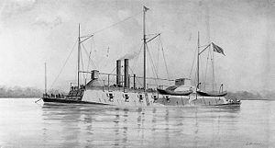
As Grant’s land forces began to assemble south of Vicksburg on the Louisiana side of the river the Union fleet made preparations for its part in the rapidly developing campaign. Rear Admiral David D. Porter issued a General Order for the running of the Vicksburg and Warrenton batteries. The detailed order described how the operation was to be conducted down to the smallest detail.
USS Benton
The order of movement was set; the flagship Benton would lead the way, followed by Lafayette with Price lashed to her side, Louisville, Mound City, Pittsburgh, and Carondelet. The combat vessels were followed by the transports; Forest Queen, Silver Wave and Henry Clay. Bringing up the rear would be the gunboat Tuscumbia.
Additional instructions set forth strict operational guidelines.
- Each vessel would tie a coal barge to the starboard (right) side. The barge would be arranged so that it could easily be set adrift. The coal would be needed to fuel the projected cross river operations.
- The ships would operate under blackout conditions.
- No vessel would travel within 50 yards of another.
- No vessel would run directly astern another to avoid collisions should the lead vessel become disabled.
- A battle carry of 900 yards would be set on the guns, but a prohibition against firing to the bow and stern for fear of accidently striking a friendly vessel was set.
- A signal system was established for accountability after passing the Warrenton guns.
At 2115 the fleet was finished with the last minute details and cast off for their cruise south. As they rounded DeSoto Point the parade of Federal ships was detected by Confederate pickets patrolling the river in small boats. In a pre-arranged response they raced for the far shore and ignited fires to backlight the Union armada as it passed the Vicksburg batteries. The slow moving vessels remained under enemy fire for the next fourteen miles. The heavily armored gunboats were struck repeatedly but suffered only superficial damage. The transports did not fare as well despite being protected by cotton and hay bails and bags of grain. The Henry Clay became disabled and was abandoned by her crew. The cotton bales designed to protect the boilers caught fire and burned her to the water line. The hull drifted down stream and was later recovered near New Carthage. The Forest Queen was also disabled but assisted for the remainder of the voyage by the Tuscumbia and arrived badly beaten up but safely at New Carthage. Besides the Henry Clay, some of whose crew were captured, the total Union losses for the two and a half hour cruise was eight men wounded, most on the Benton. Even most the coal barges cut free during the run were recovered after they drifted downstream. 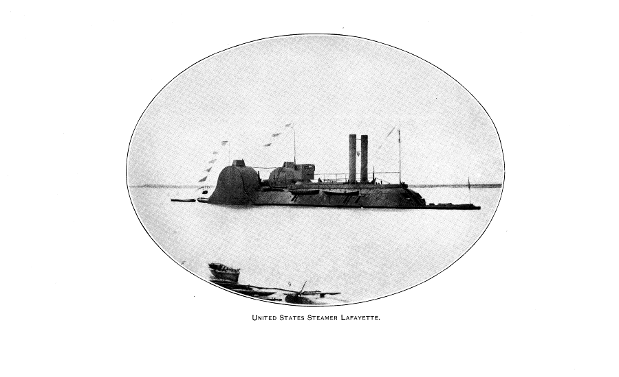
Grant was delighted by the results. The voyage was even a bigger success than he and Porter had hoped. The batteries that had been feared for months had been run with relative ease. On the 19th Grant wrote to Halleck that he intended on sending “six more steamers by the batteries as soon as they can possibly be got ready.” He also announced plans to move his headquarters to New Carthage to begin operations against Grand Gulf as soon as possible. His ambitious plan was falling into place but he still had to grab a foothold on the Mississippi side of the river.
Grierson’s Raid I
The day after the running of the batteries another large scale operation began that would have a huge affect on the campaign. The concept of a diversionary cavalry raid into northern Mississippi had occurred to Grant as early as February. With the fleet below Vicksburg he realized the time had come to initiate the plan. He hoped that the raid would be beneficial to the overall strategy in several ways.

- Focus attention away from his movements in Louisiana.
- Draw away the Confederate cavalry. Minus the intelligence gathering arm of his forces Pemberton’s reactions to his move might be slowed.
- “Playing smash with the railroads” to slow the logistical support to the Vicksburg defenders.

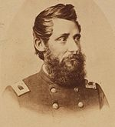
In fact Grant thought so highly of the prospects for such an endeavor that he wrote to MG Stephen Hurlbut on February 13th proposing a raid. He also designated Colonel Benjamin Grierson as the leader of the raid. Hurlbut and Grierson both agreed to the operation and the plan was finalized. The original start date of 17 February was cancelled when an intelligence report stated that there were too many Confederate troops in the area of operations to make success likely. The cancellation allowed Grierson to go home on leave to visit his family. His stay would be shortened by an urgent call back to begin the raid on April 17th.
Col Benjamin Grierson
At first glance Grierson seemed an odd choice for the assignment. His dedication to the Union caused him to serve on a volunteer basis on the staff of MG Benjamin Prentiss for nine months. His ultimate goal, as an avid musician, was to win appointment as a Regimental bandleader. When he finally was awarded a commission he was shocked to discover that he had been assigned to the cavalry. A childhood accident had left him deathly afraid of horses. Try as he might he could not get a transfer to another branch. Undeterred the reluctant trooper threw himself into his new assignment. His perseverance paid off when 37 fellow officers signed a petition to have him promoted, eventually gaining command of the 6th Illinois Cavalry. In December of 1862 he was promoted to brigade command. The raid into northern Mississippi would not be his first combat experience, or his last, but it would definitely be the highlight of a distinguished career.
When Grierson arrived back from his abbreviated leave he found his raiders waiting. The brigade consisted of the 6th Illinois Cavalry (Colonel Robert Loomis), the 7th Illinois Cavalry (Colonel Edward Prince), and the 2nd Iowa Cavalry (Colonel Edward Hatch). Attached were six Woodruff guns from Battery K, 1st Illinois Artillery, under the command of Captain Jason Smith. Grierson barely had time to receive last minute instructions before the column “slid like a huge serpent” of camp.
In an effort to disguise his numbers the column was broken into two sections. The 6th Illinois took the main road and the 7th Illinois and 2nd Iowa moved off to a parallel road several miles to the east. The 1700 Union troopers were off on a 16 day adventure that none of them would soon forget.
Grierson’s Raid II
The raid began with an unremarkable ride to Ripley, Mississippi where the two columns reunited. Only minimum resistance was encountered in the early days of the raid, almost entirely from Home Guard militia troops who proved ineffective at slowing Grierson’s column of combat veterans. It was clear, however, that the word of his movements was out and he could expect growing opposition. Grierson immediately began a series of diversionary moves intended to confuse the enemy about his true mission. These types of maneuvers would punctuate the raid and often left the pursuing Confederates grasping at air.
The first major obstacle in the path of the Federal advance was the Tallahatchie River. While the column split to move south Grierson became fearful that the bridge at New Albany might be defended. He ordered a battalion of troopers, under Major John Graham, to gallop forward and secure the crossing. A classic cavalry charge cleared the bridge of the few defenders, capturing four. Two of those captured proved to be from LTC C. R. Barteau’s 2nd Tennessee Cavalry Battalion. Now aware that he was facing a legitimate foe Grierson was forced to alter his movement plan again. The next morning he sent out three patrols to search out the enemy and establish communication with the 2nd Iowa. The first, commanded by Captain George Trafton, retraced their steps to New Albany and routed about 100 members of the Mississippi Home Guard. The second patrol found only Barteau’s empty camp and the third passed orders to Hatch’s 2nd Iowa. The patrols then met up with the 7th Illinois at Sloan’s Plantation and struck out after the 6th Illinois heading toward Pontotoc.
At Pontotoc, Grierson initiated another deception by making a difficult decision to trim his force by removing men and animals that were sickly or broken down. At Regimental dress inspections the weak were culled out and formed what quickly became known as the “Quinine Brigade”. These 175 men, prisoners, and one of the Woodruff guns, under command of Major Hiram Love, turned north in a march back to Tennessee. Marching by fours the hope was that Barteau would be duped into believing that the entire column had abandoned the raid and headed home. Barteau was momentarily confused but recovered quickly and took up the chase of Hatch’s Iowans while the main column moved on. 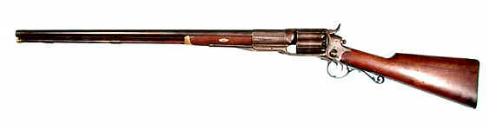
Colt Revolving Rifle
Hatch sent Company E and his sole artillery piece to create a deception of his own. The detached troopers went to the main road junction near Starkville and created enough tracks to fool Barteau into believing he was chasing the main Federal column. Barteau’s command finally caught up with Hatch near Palo Alto, Mississippi. A fierce skirmish ensued. Hatch used his sole artillery piece to break up the militia and the firepower of his Colt Revolving rifles to force the Confederates to withdraw. He then used the breathing room to start his own withdraw to the north. This move drew the Confederate cavalrymen further away from the main body. Barteau would finally break off the chase on the 24th.
The growing enemy presence created a great deal of concern for Grierson and the primary Union column. At a meeting of his commanders on the night of the 20th he sought views on how to avoid riding into a Confederate trap. LTC William Blackburn suggested that a squad of scouts be formed to ride ahead, dressed as Confederate troopers, to keep the command appraised of the situation ahead. Despite the prospect of a sure death in front of a firing squad if discovered eight men stepped forward to meet the challenge. The party, led by Sergeant Richard Surby, scoured the nearby homes for clothes and weapons to disguise themselves. On the morning of the 21st the newly dubbed “Butternut Guerillas” set out. Their service would prove invaluable.
“The most successful thing of the kind”
By the 23rd Grierson was approaching his primary objective, the Southern Railroad. Sergeant Surby and two other Butternut Guerillas rode into town and learned that two trains were expected at the station that day. A messenger was sent back and LTC Blackburn and 200 troopers were dispatched to the station. They had barely arrived when the first train pulled in. The engineer was convinced by pistol wielding troopers to pull the train off to a siding. The second train arrived shortly thereafter with 13 cars full of weapons and munitions destined for the Vicksburg area. After all the personnel and private property were unloaded the trains were torched. The resulting explosions brought Grierson storming into town with the remaining troops to do battle. Finding that their assistance was not required Grierson paroled 75 prisoners and took his troopers out of town.
On the 25th Grierson sent a lone guerilla, Samuel Nelson, to cut telegraph wires at Forest Station. Instead the unsuspecting Nelson rode directly into a regiment of Confederate cavalry intent on bagging the Union raiders. Nelson, who must have been terrified at the prospect of being discovered as a spy, convinced them that the Union column was made up of 1800 men and were heading east to tear up the Mobile & Ohio Railroad. The Confederate commander believed the story and headed off in completely the wrong direction after releasing Nelson, who rode back to warn Grierson of the enemy presence.
Grierson made a mad dash for the Pearl River at Hazelhurst. As they approached town two of the Butternut Guerillas went ahead with a bogus telegraph message for Pemberton in Jackson. The wire stated that the Union column had changed course and were headed northeast. The local telegraph operator had no reason to question the two men and sent the message on its way. The two over confident guerillas then decided to take in a meal at the nearby hotel. While they were dining they were recognized by a paroled Confederate who raised the alarm. They left town in a rush but the fake message was never rescinded.
By now Pemberton was thoroughly confused by reports coming in concerning Union raiders in every direction. In an effort to halt the raid he stripped all available cavalry from their commands to destroy Grierson. Despite the ever growing number of men dedicated to that task they would meet with no success. In a series of feints, bluffs, and diversions Grierson made his way south with the 6th and 7th Illinois. The 2nd Iowa continued north and arrived back at La Grange, Tennessee on April 26th, having lost 6 men captured, 3 wounded, and one man killed.
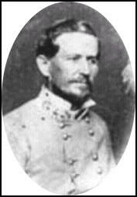
Close calls and destruction continued to mark the progress of the Union troopers. They captured 216 men at a Confederate training base at Brookhaven, Mississippi. The captives were paroled and all military stores were burned. Grierson barely avoided a trap set by Colonel William Wirt Adams and his 1st Mississippi Cavalry while trying to link with Union forces at Grand Gulf. Failure of the attempted landings there pushed Grierson southward. As they rushed toward Baton Rouge they burned a train of 25 cars at Summit, Mississippi. An encounter with the 9th Louisiana Partisan Rangers and 9th Tennessee Cavalry Battalion at Wall’s Bridge, Mississippi, close to the Louisiana border, left LTC Blackburn mortally wounded and Sergeant Surby with a severe leg wound. Captain Smith’s Woodruffs managed to turn the tide and Grierson escaped again. The wounded Surby was returned to a Federal blue uniform and left behind to become a prisoner. He was later exchanged and returned to duty.
Wirt Adams
Grierson continued south on a meandering course until he reached Baton Rouge, Louisiana on the May 2nd. The cost to the two Illinois regiments was three killed, including LTC Blackburn, 7 wounded, and 5 captured. In their nearly 600 mile wake they left an estimated 100 dead and wounded, 500 paroled prisoners, 3000 destroyed stands of arms, and tons of munitions and military supplies destined for Vicksburg. Most importantly was the attention and troops diverted away from the main arena at Vicksburg.
Pemberton seeks help
Bowen’s repeated messages of concern regarding Grant’s actions across the river barely raised an eyebrow at Confederate headquarters until mid-April. The ease of enemy movement in this area finally caught the attention of Pemberton after the Union running of the batteries on the 16th. With Federal gunboats below the city he finally understood how dire the circumstances had become. Without a Confederate naval presence there could be no movement of troops across the river to confront the growing Union strength at New Carthage. Seeking a means to slow the enemy build up in eastern Louisiana he sought assistance from the Trans-Mississippi forces of MG Richard Taylor and Lt Gen Edmund Kirby Smith. On April 17th he fired off a desperate telegraph to Taylor and Smith:
“For the want of the necessary transportation I can not operate effectually on the west bank of the river; the enemy is now in force at New Carthage and Richmond. I beg your attention to this.”
When this appeal elicited no response Pemberton tried again on the 18th.
“The enemy are cutting a passage from near Young’s Point to Bayou Vidal to reach the Mississippi River near New Carthage. Without cooperation it is impossible to oppose him. Inform me what action you intend to take.”
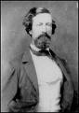
Again there was no response. Taylor can be excused for failure to take action. At that time Union MG Nathaniel Banks was mounting another of his Bayou expeditions toward Alexandria. Taylor had his hands full with a threat in his own district. Smith, on the other hand, became caught up in a cycle of inaction, inefficiency, and indecision that ended up helping either Pemberton or Taylor. Following events in both theaters he had sent a warning order to MG John G. Walker’s division of Texans and Razorbacks at Pine Bluff, Arkansas to move to Monroe, Louisiana where they would be in position to race to the aid of whichever area he deemed most critical. Unfortunately the orders for the movement of the Texas Division became fouled. Even after Smith sent orders on the 19th to “Please hasten Walkers movements” the march did not begin until April 24th. The important reinforcements did not cross into Louisiana until the 29th. On May 4th Walker’s division reached Trenton, Louisiana just two days hard march from Grant’s now decreasing forces. Instead of grasping the initiative and attempting to interdict Grant’s lines of communication the Texans made camp and waited. On May 9th Pemberton again asked for Smith to order action against Grant on the west bank of the river. He believed that a counter-logistics strike in Louisiana would pay dividends in the effort to slow the Union progress.
John Pemberton

“You can contribute materially to the defense of Vicksburg and the navigation of the Mississippi River by movement upon the line of communication of the enemy on the western side of the river.”

Instead of aiding Pemberton, Smith broke up the three brigades by sending two to help Taylor at Natchitoches. The remaining brigade, commanded by BG Henry McCulloch, continued to camp near Trenton until the 16th. On the 17th McCulloch’s men finally started to march; away from the enemy toward Campti. There the three brigades (the fourth brigade comprised of Arkansans remained at Pine Bluff during these operations) were reunited. Taylor planned on using them in an effort against New Orleans but Smith intervened. Against Taylor’s hearty protests the Texans were finally ordered into action in Madison County. It was not until June 7th that McCulloch’s men raided Milliken’s Bend while BG James M. Hawes’ brigade cancelled a strike at Young’s Point when the tactical situation proved unfavorable. These meager efforts were entirely too little and too late. The fate of Vicksburg was already sealed.
Keigwin’s Expedition
On the 17th General Grant made a visit to inspect the flooded conditions at New Carthage. He determined that it was impossible to use it as the base of operations for the amphibious assault across the river. A new location would have to be found to the south of New Carthage. On April 24th Colonel James Keigwin was ordered to conduct a reconnaissance of the road to Hard Times, Louisiana.
At 0600 on the 25th the 49th Indiana, 114th Ohio, a detachment of 2nd Illinois Cavalry, and a section of guns from a Michigan battery set out from Perkin’s Plantation. The march lasted just four miles before they came across the first burnt out bridge at Holt’s Bayou. Lieutenant Colonel Beekman, sent along on the mission for just this purpose, supervised the construction a bridge by 200 men from the infantry regiments (100 from each). An 80 foot span was constructed in a few short hours. Construction of another 120 foot span was supervised by LT James Fullyard, 49th Indiana, over Durosette Bayou during the night. The march continued the following morning until they reached Phelp’s Bayou where Harrison’s pesky Louisiana troopers had taken up a position across the water. Keigwin ordered his two guns forward “and threw a few shells” at the Confederate position. This display of strength caused the enemy troopers “to saddle up and leave in the greatest confusion.” A small rear guard was driven off after about an hour of skirmishing with two companies of Union infantry. The Confederates left one dead on the field.
Two more bridges were needed to cross but Keigwin found himself “not so well supplied with tools” for constructing the spans. A small detachment of cavalry was dispatched to scour the nearby plantations for the necessary implements. In a short time the foraging party returned with needed tools and an adequate supply of rope. The next two days were spent building while Major Hawhe led a recon consisting of two companies of the 49th Indiana and two from the 114th Ohio and cavalry in the direction of Hard Times.
Two companies of cavalry, commanded by Major Marsh, led the way out of camp on the morning of the 28th. One sergeant and ten men were detailed to watch over the important bridges while the main column moved on. A message from Major Marsh informed Keigwin that Harrison’s Cavalry was still in the area and intended on putting up a fight. Marsh also informed him that he could not move the Confederates with the forces at hand. Colonel Keigwin moved forward with the main body, but before he could arrive to render assistance heard artillery firing. A reconnaissance revealed a sticky tactical situation. Major Harrison’s feisty Louisiana troopers had selected a position at Choctaw Bayou that narrowed to just 200 yards wide. Four artillery pieces in battery were covering the only avenue of approach. The narrowness of the approach and lack of cover and concealment negated the Union advantage in manpower. Keigwin wisely opted against a frontal assault. Instead he formed a line of skirmishers and placed his two guns where he thought they might do the most damage. Lieutenant Stillman, in charge of the guns, focused his fire on the dismounted troopers who soon moved out of range leaving the Confederate guns without support. The Confederate guns remained but failed to find the range, “his shots passing over my command.” The guns were finally limbered and hauled off after a one hour gun duel.
This action represented the last significant opposition to the Union movements on the west bank of the Mississippi. An adequate embarkation point was located at Deshroon’s Landing and plans were set into motion for a move against the Confederate strong point at Grand Gulf.
Passing the Guns – 22April 1863
As Keigwin opened the road to the prospective boarding area Grant concentrated on the next phase of his plan in Louisiana. He had the necessary troops moving toward Hard Times but lacked sufficient transports to move them quickly across the river. To make up this deficit he ordered six transports to run the batteries on the night of 22 April.
The transports posed a special problem for the Union commander. While he had the power to seize the civilian craft for government use he did not have the authority to order the captains and crews to make the perilous journey. As it turned out most of them refused the opportunity. Of the six vessels that were to make the run only two captains and one crew chose to remain. Grant was forced to call for volunteers from the Army to man the boats. He sent out a plea for any man with experience operating on the western rivers to step forward. His troops did not disappoint him. He got volunteers “to take five times the number of vessels we were moving.”
At 2300 the six boats; Tigress (flagship), Empire City, Moderator, J. W. Cheeseman, Anglo-Saxon, and Horizon, left their sanctuary near the mouth of the Yazoo River. Each had been fitted out as before with cotton bales, hay, and sacks of grain to buttress them against the Confederate guns. All six had a barge full of supplies lashed to the Vicksburg side of the boat and another in tow. What they did not have was any way to answer the fire they expected to receive. All hope was pinned on making a stealthy run past the city under the cover of the pitch darkness.
This hope was quickly dashed when they were detected by the Confederate pickets as they approached the city. To light the scene for the batteries guarding the river Captain
C. J. Foster and three men from the 1st Tennessee Artillery rowed across the river and set two houses ablaze. Efforts by Sherman’s Corps to burn the houses prior to the running of the batteries by the unarmed boats proved unsuccessful. Two patrols that were sent out to accomplish this task were turned away by artillery fire during the day (17 shots) and heavy pickets at night. Sherman wrote to Grant on the 21st that despite “of all we can do, they can light up this shore”. His prediction proved accurate and the fires caused the river to become “light as day” and the Confederate gunners had no problem finding the range on the slow moving targets. The lead boat, Tigress, received 35 hits, the most damaging opening a four foot hole near the water line to the stern. Colonel William Oliver, acting as commander, had his crew, 41 members of the 7th Missouri Infantry, cut loose the barges and began damage control operations. It was not enough, however, and the Tigress was grounded on the Louisiana shore. The crew was taken up by the Cheeseman and the vessel broke up and sank.
The Cheeseman also made a valiant effort to assist the stricken Empire City. The disabled boat was taken under tow until they approached the Warrenton batteries. There she was cut loose when she made control of the Cheeseman difficult. The Cheeseman then ran by the Warrenton guns and came to and waited the arrival of the Empire City just out of range as she drifted lazily past the batteries. Amazingly the slow moving boat survived the ordeal. Their only protection was the low hanging gun smoke that partially obscured them from the guns.
On the Anglo-Saxon things were equally as rough. A shot through the bow forced captain Leander Fisk to cast off his barges. Another shot crippled the starboard engine and set the boat adrift. As the river current dragged the helpless boat past the remaining guns she was struck by 30 more shots. In a moment of panic a small party abandoned ship in a skiff. Somehow in the effort two men, J. H. Miller and A. B. Turner were lost, presumably drowned. Remarkably they represented the only fatalities on the boat. After passing the Warrenton batteries she was taken in tow by Horizon, commanded by Captain George Kennard, until that boat was relieved by the Silver Wave that came rushing up from New Carthage to assist. The Moderator also became disabled and eventually drifted to safety, although severely damaged.
Despite the unarmed nature of the targets the passing of the boats was not a bloodless event for the Confederate gunners. A 10-inch Columbiad burst during the barrage killing one man outright and badly wounding two others. Under the storm of 391 shots fired by the enemy guns the six transports had cut loose their barges. Of the twelve only six were later recovered. The transports had been badly shot up but Admiral Porter immediately put his experienced sailors to work on the repairs. Grant did not have all the assets he wanted but he now had all he needed for a cross river expedition.
Hayne’s Bluff Diversion
In conjunction with the attack on Grand Gulf Grant envisioned a diversionary attack north of Vicksburg in the area of previous bloody repulses. The intent of this operation was to prevent Pemberton from rushing reinforcements into the area of his projected landings. Grant was keenly aware of the criticism that was leveled against him for early failures in the campaign and did not want to expose himself or his subordinate commanders to unnecessary attacks by an ill informed press. Grant believed that a diversionary attack that was pulled back after accomplishing its designed mission would be misinterpreted as another defeat. In a concession to the possible public opinion reaction to such a “failure” he did not order Sherman to conduct such an operation. Instead he “suggested” that a deception in this area would prove useful to the overall scheme of maneuver. Grant wrote to Sherman on the 27th;
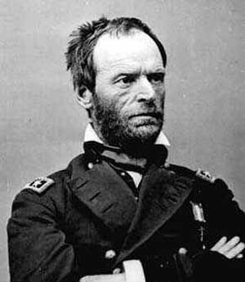
“If you think it advisable, you may make a reconnaissance of Hayne’s Bluff… The effect of a heavy demonstration in that direction would be good …. But I am loathe to order it, because it would be so hard to make our own troops understand that only a demonstration was intended, and our people at home would characterize it as a repulse….I therefore leave it you whether to make such a demonstration.”
William Tecumseh Sherman
Grant also advised his subordinate to make sure written orders were in place defining any such move as a diversion, so evidence to that affect would exist prior to the operation. Sherman cared little about the opinion of the press and took the “suggestion” as an order. He immediately formulated a plan to conduct the demonstration in support of Grant’s Grand Gulf move. Writing to Grant on the 28th he justified his decision;
“You are engaged in a hazardous enterprise and for good reasons wish to divert attention; that is sufficient to me and it will be done.”
As far as public outcry was concerned Sherman scoffed at the idea. He wrote “the people must find the truth as they best can; it is none of their business”.
While two of his divisions moved toward a rendezvous with the rest of the Army at Perkin’s Plantation Sherman had ten regiments of Blair’s division boarded on a fleet of ten transports. They were escorted up the Yazoo River by Tyler, Choctaw, DeKalb, Signal, Romeo, Linden, Petrel, and Black Hawk. The gunboats engaged the Confederate batteries while the troops disembarked at the site of the bloody fiasco of 29 December 1862. As the troops marched out “and made disposition as for attack, the boats maintained a steady fire. Their fire was returned with great effectiveness. The Choctaw was struck 53 times and the Tyler was struck in the starboard and was forced to retire for repairs. She patched the hole in her side and took up station down river to prevent the placement of additional batteries. As the DeKalb was retiring from the action she was fired on by musketry coming from some shore line buildings. In the biggest action involving ground forces during the entire diversion a 25 man boarding party, led by Acting Master C. S. Kendrick, was put ashore. They battled members of 3rd Louisiana Infantry for possession of the buildings. The Navy men proved as adept with small arms as they were with their big guns. The encounter left 4 Confederates dead, one major and three privates, and another officer (lieutenant) prisoner. The remainder of the force was sent fleeing through the swamp.
The performance was repeated the next day and had an immediate impact on the Confederate commander in Vicksburg. BG Carter L. Stevenson responded to reports by reversing a column intended for Bowen at Grand Gulf. Stevenson wired Pemberton in Jackson that;
“The gunboats have been engaging Synder’s (Haynes Bluff) since 9 o’clock. Have sent reinforcements to that point.”
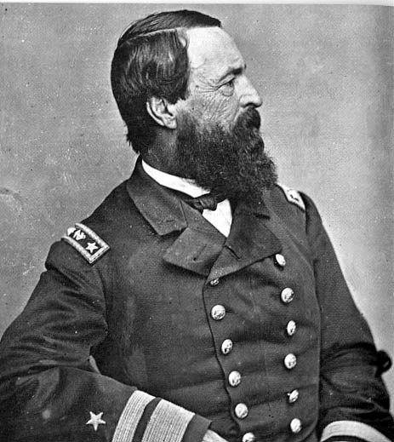
The success of the diversion was tempered by Porter, who felt he had been deceived by the nature of the mission. His understanding of the proposed action did not include engagement of the batteries. He chastised Lieutenant Commander K. R. Breese, commander of the operation, for placing the boats in danger. In a message to Breese he stated the mission;
Admiral David Dixon Porter
“Which you call a feint, but which I consider an unnecessary exposure of the vessels. The results were unfavorable to us and the affair will be considered a defeat.”
He tempered his criticism in a message about the “affair” to Secretary of the Navy, Gideon Welles, stating that the vessels had been put under fire unnecessarily but since there were few casualties “it mattered but little.” Naval second guessing aside the operation had been an unquestioned success.
Grand Gulf
With the gunboats and necessary transports now below the Vicksburg and Warrenton batteries Grant could turn his attention to moving his army across the river. The plan was a reduction of the enemy forts at Grand Gulf and landings there. The plan made good sense; if Grand Gulf could be taken the Union forces would not only have removed a significant Confederate military presence but also gained an excellent base of supply for inland operations. A beachhead there would also open the opportunity for a direct move against Vicksburg from the south or if the situation called for it a move eastward against the capital, Jackson. The two Confederate forts there were well positioned and represented a major challenge to Grant’s plan. The Union commander again called on his naval counterpart, Porter, for assistance. Porter was busily tending to the repair of his fleet but accepted the challenge. An attempt at reducing the two forts was set for April 29th.
The assault was elaborately planned by Porter to the smallest detail. He issued instructions to his commanders on April 27th. The attacking force would consist of:
Benton – The converted center wheeled catamaran snagboat served as the flagship for Porter’s armada. She was considered the most powerful warship on the Mississippi. She was armed with 16 guns of various sizes.
Louisville, Mound City, Carondelet, and Pittsburg - The four City Class ironclads were identical in layout but each packed a different array of guns ranging in size. Totaled they added 48 guns to the fight.
Lafayette – This former side wheeled merchant steamer was armed with two 11” Dahlgrens, two 9” Dahlgrens and two 100 pounders. She had seen action on the 21st when she chased the Confederate supply ship Charm back up the Big Black River when she tried to supply the Grand Gulf defenders.
Tuscumbia – An awkwardly shaped steamer that carried three 11” Dahlgrens and two 9” Dahlgrens.
Price – this former Confederate ram carried no significant armament and was ordered to lay off at 1000 yards with two disabled transports in tow. Once the Confederate batteries were engaged she began a run down the far side of the river at top speed. She was struck three times but delivered her charges safely.
The City Class boats were to attack and reduce the lower fort and then move up river to assist Tuscumbia, Lafayette, and Benton at the more formable upper fort. Porter instructed his commanders :
“Louisville, Carondelet, Mound City, and Pittsburg will proceed in advance, going down slowly, firing bow guns at the guns in the first battery (Fort Cobun) on the bluff, passing 100 yards from it, and 150 yards apart from each other.”
The four ironclads would then move down river to take the lower fort (Fort Wade) under fire. The impressive armada left New Carthage and fought their way into their assigned positions. Once the fleet was in place a furious five and a half hour gun battle ensued. The rugged ironclads managed to silence the guns at the lower batteries and moved up to join in the attack on the upper guns. Pittsburg arrived just in time to aid the stricken Benton. During the bombardment the Benton was caught under fire of the Confederate guns after her steering was crippled by a shot through the pilot house. The Pittsburg was brought along side by Acting Volunteer Lieutenant Hoel to absorb the pounding while pushing the Benton to safety. She suffered the only casualties among the City Boats while accomplishing this feat. Her losses were 6 killed and 13 wounded. The act entered Hoel into Navy history as a hero and lent his name to a Fletcher class destroyer launched in 1942 (DD533).
Despite the heroism Porter eventually had to admit that the task of defeating the upper guns was impossible. He decided to save his fleet from further pounding and retired to New Carthage where he called Grand Gulf “the strongest place in Mississippi.” The action resulted in 80 casualties and left the fleet “much cut up.” The casualties included members of Co. D 29th Illinois (1K, 2W) and seven companies of the 58th Ohio (6K, 8W) who were on detached service to Porter’s fleet. Porter reported to Grant, who conceded that any attempt at forcing a landing with the guns at the upper fort still in operation would cause unnecessary casualties. Another new plan would have to be made if the guns of Grand Gulf were to be avoided.
Bruinsburg
The failure of the Grand Gulf assault, although disappointing, did not end Grant’s cross river ambitions. After a short consultation with Porter he decided to try a landing south of Grand Gulf, but first he had to get his transports to Hard Times from New Carthage. This trip would require them to sail past the same batteries that had proven so destructive to Benton, Tuscumbia, and Pittsburg. Again Grant called on Porter to occupy the Confederate gunners while the remaining transports dashed past the guns under the cover of darkness.
At 1800 Porter pulled the four ironclads, Lafayette, and Benton back in front of the Confederate batteries and opened a diversionary fire. By 2145 all the transports had safely passed and Porter could withdraw his boats. The night time duel with Confederate gunners continued the pummeling of the Union fleet. Lafayette was struck 16 times, Benton 6 times, Pittsburg twice and Mound City “was struck several times” and suffered the only fatality in the night operation, 1SG Fritz Vernold of Co. A 58th Ohio. The most serious damage, however, occurred when Louisville collided with the port side of Mound City while the two boats were maneuvering for firing position. Despite the damage the fleet had accomplished the mission and Porter could proudly announce “we are now in a position to make a landing where the general pleases.”
While porter provided cover for the movement of the transport vessels Grant was busy with intelligence gathering operations. He dispatched reconnaissance parties across the river seeking information on possible landing sites and roads inland in the vicinity of Rodney, Mississippi. One of these parties returned with a contraband that was shuffled into the headquarters. Grant recalled the episode in his memoirs stating;
“…that night a colored man came in who informed me that a good landing would be found at Bruinsburg … from which point there was a good road leading to Port Gibson.”
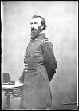
Once the site of a trading post set up by future President Andrew Jackson, Bruinsburg had been a thriving river community. The war and the resulting cessation of river commerce had brought activity to a halt and the landing was nearly deserted. A short distance away the stately Windsor Plantation was the only reminder of the areas past prosperity. The landings were set for Bruinsburg the following morning. Out of range of the Grand Gulf guns and with no threat of Confederate naval interference Grant was free to use all his naval resources to move troops. The loading of the boats commenced at 0500 when the 46th Indiana marched on board the lower deck of the Benton and the 24th Indiana the upper deck. General Grant and Admiral Porter took up station in the wheelhouse. As they approached the far shore the guns were cleared for action but “nothing, however, was visible on land that indicated that the enemy was prepared for the movement.” All the available gunboats, transports and barges were crammed full of McClernand’s XIII Corps troops to make the crossing. Much to Grant’s relief by late in the afternoon 17,000 Federals soldiers were safely on Mississippi soil. Without cavalry to picket the shore and relay information about the landing sites and without sufficient force to challenge the landings even if he had known the location Bowen was stymied. Pemberton’s inaction to his repeated warnings left probably the most important battle of the campaign unfought. Had Pemberton moved reinforcements south in response to the tactical intelligence provided by Bowen he may have enjoyed numerical superiority at the beach head. Instead he left Bowen under strength and blind to challenge the Union host that was arriving in his sector.
John McClernand
It is easy to dismiss this unopposed operation as unimportant but the movement across the river transformed Grant’s Army of the Tennessee from a caged tiger to a dangerous animal free to stalk its prey.
Breakout
The movement off the beach head was delayed when it was discovered that McClernand’s troops had not been adequately provisioned. With the last minute change in plans McClernand had rushed his troops to Hard Times and logistics had been overlooked. Now on the Mississippi side of the river they needed provisions before they could move forward. A lengthy delay was caused while three days rations were ferried across the river and distributed. As soon as the rations had been issued another problem became evident. No wagons had been allowed across the river while troops were still being moved. Transportation of food and ammunition from the landing had not been considered. Of the two items Grant considered ammunition more important. He ordered that any and all animals be seized to haul the heavy burdens. Horses, mules, oxen, and even dogs were used to drag the ammunition forward in “a motley train” of wagons and carts. Thomas Durham, a soldier from Indiana, recalled that the collection of oddly teamed animals and vehicles amounted to “no such sight has ever been seen since old Noah entered the Ark”. The over burdened infantry troops were no less resourceful and innovative. Already weighed down with haversacks full of sixty rounds of ammunition and rations the soldiers fixed bayonets and stabbed through meat rations that no one wanted to leave behind. The weapons were then set to right shoulder shift with the precious cargo stuck to the end.
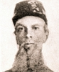
The main Federal column finally set out at 1730. For some unknown reason, probably faulty maps and lack of knowledge about the surrounding area, the lead element, 21st Iowa, avoided the most direct route, the Bruinsburg Road, and headed south in the direction of the Bethel Church. Their objective was the small crossroads town of Port Gibson. Roads from the town led to Vicksburg, Grand Gulf, and Jackson as well as the all important bridges across the Bayou Pierre which served as the last significant terrain obstacle to the Confederate bastion at Grand Gulf. Possession of the town would give Grant a numbered of tactical alternatives that would prevent the Confederate response from consolidating against any one attack. In the vanguard of the column Colonel Merrill place a 16 man patrol led by LTC Cornelius Dunlap. Their orders were to advance “until fired on by the enemy”. Shortly after midnight they neared the Shaifer residence.
The Union troops were not the only ones marching. Left to his own devises for this long Bowen was finally getting some attention paid to his rapid fire stream of messages warning of the impending Union movement. Reacting to the sound of guns at Grand Gulf, Stevenson released the brigades of BG Edward Tracy and BG William Baldwin to move to Bowen’s assistance from Vicksburg. While he waited the arrival of the much needed reinforcements Bowen proceeded to make dispositions with the troops he had available.
BG Martin Green
Lacking cavalry (Adams was still off chasing Grierson), Bowen sent about 400 men from BG Martin Green’s Arkansas Brigade to patrol the roads and establish an initial position near Port Gibson. The vanguard was comprised of the 21st Arkansas (-), 15th Arkansas and 12th Arkansas Sharpshooters under the command of Colonel J. E. Cravens. Bowen had to be careful not to strip away too much of his force. If the Bruinsburg landings proved to be a feint then Grant could use his gunboat access to Bayou Pierre to land a force to attack Grand Gulf directly. Accordingly he left Cockrell’s Missouri Brigade there as protection and to serve as a reserve until the situation was developed.
BG Green arrived with the attached 6th Mississippi and additional artillery on the 30th and true to his aggressive nature began pushing his men forward. They established a defensive line across the Rodney Road near the Union Church. Tracy’s much fatigued brigade arrived at 2200 and set up a similar position on the Bruinsburg Road on Green’s right. In between the two positions was a nearly impassable terrain formed by ravines and heavy scrub vegetation. Green also dispatched Lieutenant William Tisdale and four soldiers of Company B, 12th Arkansas Sharpshooters to act as an early warning system. The small group established an outpost in the vicinity of the Shaifer House. The stage was set for the first large scale engagement of the 55 days. Approximately 6000 Confederates stood in the path of 22,000 Union soldiers.
Port Gibson – Rodney Road
After midnight BG Green rode out personally to check on his outpost at Shaifer House and consult with LT Tisdale. As he tried to calm the nervous residents there a fusillade of bullets struck the wagon that they were preparing for their ride out of harm’s way. LTC Dunlap’s patrol had arrived and both the civilians and BG Green beat a hasty retreat; Mrs. Shaifer to safety and the general to warn his main line of troops.
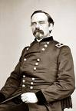
The Union advance hastily overcame LT Tisdale’s small band but were treated to a rude surprise when they neared the main Confederate position. A volley was delivered at 50 yards by soldiers of the 12th Arkansas Sharpshooters who were hidden behind a fence. The surprise encounter in the dark caused the Union Brigade commander, Colonel William Stone, to deploy not only the remainder of the 21st Iowa but the rest of the brigade as well. Two batteries of artillery were brought up, 1st Iowa and 1st Indiana, and the next three hours were spent in a gun duel and skirmishing. Darkness however prevented full scale operations. Stone, unwilling to risk night operations and the chance of running into a Confederate trap decided to wait until sunrise before making any bold move.
At the river darkness was also playing havoc with Grant’s plan. Despite fires to illuminate the way and other precautions Horizon collided with Moderator while shuttling arms and supplies to the eastern side. Horizon went to the bottom with all the horses and equipment of an Illinois artillery battery. Grant was forced to cancel the shuttle until daylight or risk the loss of the valuable boats.
BG Peter Osterhaus
In preparation for the renewal of hostilities McClernand ordered BG Asa Carr to fully deploy his division against Green’s position. In accordance with these orders Stone’s brigade was joined by BG William Benton’s brigade. BG Peter Osterhaus was sent to deploy his division against Tracy on the Bruinsburg Road.
At 0630 Carr started Benton’s brigade forward in an effort to push Green off the ridge near the church. The Confederate skirmishers were pushed back on to the main line. The defense there quickly ran into trouble against the staggering odds. At about 0700 the supporting artillery reported that they were out of ammunition. Green sent a courier to Tracy asking for one regiment of troops and a section of guns. Tracy, not yet under full attack, reluctantly agreed and sent the 23rd Alabama and a section of Johnston’s (Anderson’s Battery) 12 pounders to assist. The reinforcements arrived about 0830 “under a heavy fire, and took position and fought bravely.” Green’s line was also buttressed by two resupplied guns of the Hudson Battery, under LT John Sweaney, that had withdrawn earlier. Despite a heroic effort the position could not be held and Johnston’s guns were reversed.
Bowen understood the importance of the ridge to his position and led a counter attack by the 6th Mississippi and 23rd Alabama to retake the position. The effort was bloodily repulsed by Union artillery firing double canister. The unequal contest could not be maintained so Green ordered a withdrawal to avoid disaster. At 1100 the Confederates made their way back along the road in orderly fashion. About a mile and a half up the road they ran into Baldwin’s brigade as they were making their way to the sound of the guns.
Baldwin’s men established a line across the Rodney Road about two miles southwest of Port Gibson while Green reorganized his troops. The 17th Louisiana and the 4th Mississippi were quickly engaged by the pursuing Federals. “The fire was kept up with but little intermission along our front until between 3 and 4 p.m.” Cockrell arrived with two of his Missouri regiments, 3rd and 5th, and were sent to the far left to match the expanding Federal front. To break the stalemate Bowen ordered Baldwin and Cockrell to advance against the Union troops in their front to “try their strength.”
The 46th Mississippi was brought on line from a reserve position and preparations were made for the attack. Heavy fire of grape and canister prevented all but the 4th Mississippi from stepping off on the assault. The unfortunate 4th moved right into the guns of two waiting infantry brigades. Cockrell’s men fared no better. His movement had been discovered and carnage awaited his attack, after an hour of brutal fighting Cockrell retreated with staggering losses (13k, 97w, 96m). The Confederates were forced to retreat to their start position where they faced an immediate Union counter attack.
The Confederate batteries checked the Union advance but “in doing so killed and wounded several of our own men.” The situation stabilized until 2100 when withdraw across the Bayou Pierre was ordered. After his command had crossed the bridge was burned and Baldwin reported to Bowen near the two primary bridges across the bayou.
Port Gibson – Bruinsburg Road
BG Edward Tracy’s position on the intersection of the Shaifer Road and Bruinsburg Road held double importance. Not only was it essential to the effort to delay the Union juggernaut but should it fall then Green’s forces would be cut off from their escape route over the Bayou Pierre. Tracy’s men relieved a company from Green’s command on the night of the 30th and established a position on a ridge about a mile north of the Shaifer House. The exhausted men dropped to sleep almost immediately after assuming their positions. They were awakened by artillery fire at the Shaifer House to discover that they were oriented in the wrong direction. Originally emplaced to protect against an advance from the west they now realized that the primary threat lay to the south. Tracy altered his position by executing a change of front in the darkness.
At 0530 their new position was identified by McClernand. He became concerned that Tracy’s Confederates posed a threat to the rear of Carr’s division as it moved against Green. He immediately dispatched four companies of the 33rd Illinois to keep an eye on the threat while he scrambled to counter the threat. Tracy also saw the opportunity and began to deploy his forces for an advance. He filled the gap created by the departure of the 23rd Alabama (sent to reinforce Green) with the 30th Alabama while skirmishers from the 30th Alabama moved south along the Shaifer Road. After about a quarter mile advance the Confederate vanguard ran into the 33rd Illinois skirmishers moving in the opposite direction to establish a picket line. Like the fight on the Rodney Road the collision of these two small parties escalated very quickly.
BG Peter Osterhaus was ordered to develop the fight with the lead elements of his division as they came on line. The 7th Michigan Artillery prepped the field with a forty-five minute barrage before the 7th Kentucky and 49th Indiana started up the road. Tracy also got much needed help when the 46th Alabama and another section of guns arrived at 0800 after a long march from Vicksbug. Nevertheless the 31st Alabama skirmishers were pushed back on to the main line.
At 0845 Osterhaus sent the 42nd Ohio, 16th Ohio, and 22nd Kentucky on an assault into the center of the Confederate line. Using the ravine rutted terrain as a natural fortress Tracy’s men mowed down the Union attackers. Osterhaus determined “it would have demanded too great a sacrifice of life to have persisted in the attack.” The Federal attack inflicted a serious loss on the Confederates however. BG Tracy was dead at one of his batteries and command fell to Colonel Isham Garrott, 20th Alabama. Garrott admitted in his official report that he “knew nothing of the plan of battle” and dispatched a courier to Bowen for instructions. At 1100 the messenger returned with little guidance other than the position “was to be held at all hazards.”
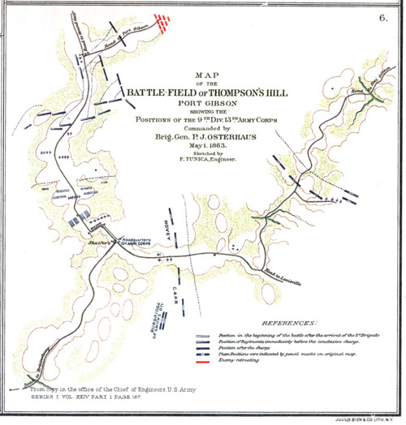
Osterhaus, meanwhile, had decided that the best chance of defeating the Confederate defense was to hold the main line while a flanking movement was made by follow on troops. His recommendation was sent to the rear and adopted by Grant who detailed McPherson’s Corps to conduct the flanking maneuver. McPherson’s gave the mission to his lead division, under the command of MG John Logan. Logan’s men took three hours deploying for the movement.
Garrott did not waste the time the Federal deployment granted him. He sent an urgent request to Bowen for reinforcements and ammunition. Bowen had little to offer him but Green’s battered command that had reorganized behind Baldwin’s line plus the newly arrived 6th Missouri from Cockrell’s brigade to help Garrott hold the line against the rapidly growing Union strength. Green led the reinforcements “as speedily as the wearied condition of my men would admit.” Upon arrival Green, without consulting Garrott, fell in on the left side of the contracted Confederate line instead of the badly used up right.
According to Osterhaus, whose report did not appear in the original OR’s, McPherson’s men ignored the flanking maneuver and attempted a frontal assault of their own and were bloodily repulsed. At 1600 McPherson’s troops finally moved around the Confederate right giving Osterhaus an opportunity to attack the weakened center. Colonel Eugene Erwin of the 6th Missouri, sensing the impending disaster ordered his men to fix bayonets and charge the Union line in a desperate spoiling attack. After a ninety minute struggle against overwhelming odds the 6th Missouri was forced to retreat. The time bought by this gallant action allowed Garrott to begin the withdrawal of the remainder of the Confederate force across Bayou Pierre. Erwin’s action saved many of Tracy’s (Garrott’s) brigade but cost him 82 casualties out of 400 men. The fight at Port Gibson was over.
The Confederate actions at Port Gibson represented a brilliantly led delaying action. Bowen’s superb leadership, the excellent execution by his subordinate commanders, and stubborn battle waged by the severely outnumbered Confederate troops was wasted however. No significant action was taken by Pemberton to reinforce the effort and defeat the Union force before they could consolidate. Grant was loose in the interior of Mississippi.
Port Gibson - Aftermath (May 1-2, 1863)
As night closed in on the Port Gibson battlefields the situation calmed. The Confederate forces made an unmolested retreat across the Bayou Pierre as the exhausted Federal troops paused. The horrible work of recovering the dead and wounded was begun. A curious Fred Grant, the general’s son, decided to lend a hand. A brief look at the mutilated corpses was enough to scare the young man away from that detail. Instead he moved on to assist with the wounded at a field hospital that was being established at a log house nearby. He found the situation there equally disturbing. He later wrote of the experience;

“The scenes there were so terrible that I became faint and ill and making my way to a tree, sat down, the most woe-be gone twelve year old lad in America.”

The day long fight had been costly for both sides. Union losses totaled 975 (131 killed, 719 wounded, 25 missing) while the partial returns from the Confederate forces set the toll at 832 (68 killed, 380 wounded, 384 missing). Despite the heavy losses Grant was determined to take up the fight on the morning of the 2nd.
At dawn the Union troops moved forward to find that the stubborn Confederates had left the field. Bowen had moved his troops first across the Little Bayou Pierre and then Big Bayou Pierre, burning the bridges behind them. At 0900 they finally made camp. The exhausted men fell on their arms.
There was no hiding Grant’s whereabouts or intentions now. The light finally came on in Pemberton’s brain. He wired Jefferson Davis that Grant’s seizure of a foothold in Mississippi had “completely changed (the) character of defense.” He told Davis that;

“Large reinforcements should be sent to me from other departments.”

He feared that Jackson was threatened and a successful march on the capital would isolate Vicksburg. He did not, however, take advantage of the time gained by Bowen’s valiant action. He did not significantly reinforce Bowen.
When he realized that he would receive only minimal assistance from Pemberton, Bowen abandoned the idea of defending the crossings of Bayou Pierre. He moved north of the Big Black. Not only was a strong position at a natural obstacle and choke point given up without a fight but he also ordered Grand Gulf evacuated as well. With the Bayou undefended defense of the fortress was made untenable by Grant’s gains at Port Gibson. The magazines were destroyed but nine of the large guns were left in place. Without firing a shot Grant gained a river position that was adequate as a supply point for upcoming operations. Grant also called forward his most trusted subordinate. General Sherman brought his XVth Corps across the river on the 7th while engineers bridged the Bayou Pierre. Having successfully grasped the initiative from the Confederates Grant now had to decide the next move.
A Change in Plans
Firmly established in Mississippi and facing an outnumbered and indecisive opponent Grant re-evaluated his plans. The original concept of operations was to capture Grand Gulf, consolidate his strength, and build a logistical foundation for future moves. While he was accomplishing this McClernand’s Corps would be turned southward to cooperate with MG Nathaniel Banks effort against Port Hudson. Once that river bastion was taken the two would reunite with Grant for the move against Pemberton and Vicksburg.
The plan, however, had developed its first major flaw. Banks move against Port Hudson had not kept pace with Grant’s rapidly developing campaign. If McClernand were dispatched to that area then he would be operating alone. Grant thought better of that possibility and decided to keep his forces intact. A new plan was developed on the fly.
The situation offered Grant several intriguing opportunities. He could move directly against Vicksburg or Port Hudson. Instead of a direct confrontation against the well developed defenses of any of these Grant adopted an indirect approach. Using reports from patrols sent out to the various places of interest establishing the Confederate defensive posture at each Grant determined that direct action would be wasteful. Instead he decided to further isolate Vicksburg by cutting the line of communication between there and Jackson. Inserting his forces in this fashion would accomplish several worthwhile tactical goals:

- Avoid unnecessary losses that would surely accompany a direct approach.
- Interposing his command between the two primary enemy forces in the area would prevent them from consolidating against him.
- By creating options for himself (Vicksburg or Jackson) he continued to confuse an already overwhelmed Confederate command structure.
- Supplies going to Vicksburg would be interdicted

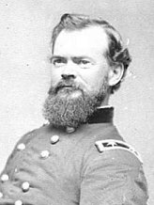
The new plan had one great drawback. There had not yet been time to establish a firm logistical support system to support his troops. To wait for such a system to be developed would cede the all important initiative to Pemberton. Not wanting to give Pemberton time to get organized and reinforced Grant decided to load the available supplies on the backs of his troops and the small number of wagons that had been brought across the river and move without delay. Supply deficiencies would be made up by foraging off the local economy. Embarking on operations with a solid supply base was contrary to accepted military knowledge of the day but Grant understood that time was more important to the success of his campaign. The longer he waited the greater the chance that Pemberton would assemble his forces against him.
Because Sherman’s divisions were not yet ready to lead the march as intended, Grant selected McClernand’s men to lead the way. On the morning of May 7th the Army of the Tennessee moved out from the base it had occupied for three days at Hankinson’s Ferry in the form of a trident. McClernand’s corps headed northeast toward Old Auburn along a trace of the south bank of the Big Black River forming the northern tine. Sherman would organize his divisions and then set out after McClernand assuming the center tine position near Cayuga. McPherson’s troops would move directly east along the Bayou Pierre and then northeast toward Raymond as the southern most tine.
James McPherson
The Federal troops experienced little more than ineffectual skirmishing on the first four days of their march. The untouched Mississippi countryside provided ample supplements to daily rations. On the 12th the lead elements of McPherson’s Corps approached Fourteen Mile Creek near Raymond, Mississippi.
Raymond – Miscommunication and Miscalculation (May 10-11, 1863)
As the Union trident was marching forward, BG John Gregg’s Confederate brigade was completing a lengthy journey of their own. Gregg’s 3300 man unit had barely finished a grueling 200 mile march from Port Hudson to Jackson when they were ordered to march “promptly to Raymond.” Additional instructions called on him to use Wirt Adams’ cavalry for reconnaissance and advanced pickets. This began another breakdown in the Confederate command structure that would have serious consequences for Gregg’s troops.
When Gregg arrived at Raymond on May10th he found only one sergeant (Miles) and four troopers from Adams’ command there. Adams had received an order from Pemberton to “direct your cavalry there to scout thoroughly, and keep him (Gregg) informed.” Adams wrongfully believed that this order meant that his troops already in the area (5 men) were to remain and fall under the control of Gregg. His understanding of the order led him to believe that he need not move the remainder of his command to Raymond. The failure of Adams to unite with Gregg as intended left Gregg woefully short of intelligence gathering assets.
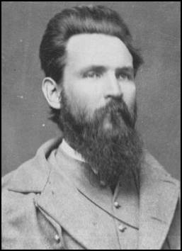
Lacking veteran cavalry, the onus of Gregg’s reconnaissance effort fell to Captain Hall and a group of about 40 state militia troops. The state troops were comprised mostly of youth from the area that were not yet old enough for regular service. The group was game for the assignment but terribly inexperienced. Gregg immediately sent a request for additional troops from Adams, who sent a squadron under Captain W. S. Yerger. They arrived on the night of the 11th. Because they reported a short skirmish in the vicinity of Dillon’s Plantation they were dispatched to cover the roads to the northeast, or precisely the opposite direction of the Federal advance.
Early on the morning of the 12th Captain Hall’s young scouts reported the approach of McPherson’s column. Lacking vital information Gregg “was unable to ascertain anything concerning the strength of the enemy.” To compound his difficulties Gregg somehow assumed from a message sent by Pemberton that he was facing a brigade sized flank guard. He reported that this belief was confirmed when Hall’s untrained scouts put the estimate of the Union numbers at 2500 to 3000 troops.
Gregg saw an opportunity in the estimates. “Believing from the evidence I had that his force was a single brigade” Gregg made “dispositions to capture it.” His plan was to pin the head of the column outside of town and then flank the enemy destroying or capturing the lot. He selected the 7th Texas and the 3rd Tennessee as the attacking force. The 50th Tennessee and the consolidated 10th/30th Tennessee were to act as the flankers. The 1st Tennessee Battalion remained in support of Hiram Bledsoe’s battery and the 41st Tennessee acted as a reserve. Everything was in order. The ladies in town began preparations for a picnic lunch for the Confederate soldiers in expectation of their victorious return.
BG John Gregg
Unfortunately Gregg’s intelligence was flawed. In fact the estimate was grossly incorrect. Gregg faced not 3000 enemy troops but nearly five times that number. This miscalculation would have profound and deadly effects for two of his best regiments. The horrible results of the mix up would play themselves out at Fourteen Mile Creek.
Raymond – Gregg’s Attack (May 12, 1863)
In accordance with his orders MG James McPherson marched his men toward Raymond on the morning of the 12th. MG John Logan’s 3rd Division led the way down the Utica Road. Colonel Manning Force recalled the scene this way;“…the 20th Ohio marched as advance guard of the division, on the right of the road to Raymond, with four companies deployed in front as skirmishers…” At 0900 artillery fire from Hiram Bledsoe’s Confederate artillery and increased skirmishing stopped the column about a mile and a half south of town. The lead brigade, under BG Elias Dennis, formed a line of battle parallel to Fourteen Mile Creek. The brigade of John E. Smith moved up from their trail position and formed on their right. The 23rd Indiana was ordered ahead and disappeared into the wood line to cross the creek and set up a skirmish line.
The 20th Ohio was also ordered forward in reaction to the increased skirmishing activity in their area. The 78th Ohio on their right remained on the south bank on the creek awaiting orders so the 20th advanced alone. Colonel Manning Force led his men into the trees and across the creek. While they were scrambling over the far bank the 7th Texas Infantry came screaming out of the woods. Sergeant Oldroyd of the 20th Ohio remarked at the total surprise of the assault stating,

“The battle today opened very suddenly…some cooks, happening to be surprised near the front, broke for the rear carrying their utensil. One them with a kettle in his hand …met General Logan and cried ‘Oh General, I’ve got no gun, and such a snapping and cracking as there is up yonder as I’ve never heard before.’ The General let him pass to the rear.”

The fight opened at about 50 yards and the distance closed quickly. The Buckeyes reacted instinctively and jumped back into the creek bed which formed a natural parapet. The two sides blazed away at each other from a distance of 15 or 20 yards. In some places the fighting became hand to hand as the Texans became desperate to capitalize on their early success. MG John Logan, 3rd Division commander, was everywhere encouraging the men to remain steadfast. With the help of DeGolyer’s Michigan battery, serving in close support, the ferocious Confederate advance was stalled in front of the stubborn Federals.
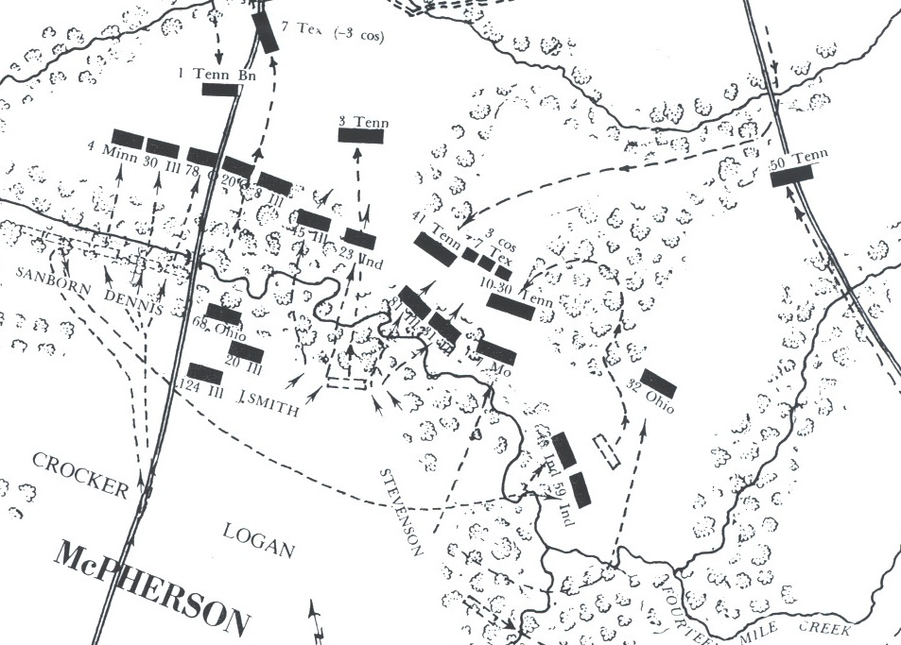
On the Buckeyes right the 23rd Indiana had just completed their own difficult crossing of the steep banked creek and were somewhat disorganized when the 3rd Tennessee charged out with a yell and caught them completely by surprise. The Hoosiers managed just a ragged volley before the two forces were intertwined. The Federal soldiers did not have time to fix bayonets and most of the Confederate troops lacked the device. A brutal clubbed musket and short range duel ensued and continued for about ten minutes until the Union troops “being overpowered by numbers” began to fall back. The creek proved to be as much as an obstacle going back as it had coming in. The retreat disintegrated into confusion until LTC William Davis finally got the regiment reformed behind the 20th Illinois. There the 20th and 23rd would face the Confederate onslaught alone. The remainder of the brigade had become separated while trying to maneuver through the dense underbrush.
Battle of Raymond
On the Confederate left the 3rd Tennessee was having better luck. The 20th Illinois met the retreating 23rd Indiana just as they emerged from the tress on the south bank. LTC Evan Richards ordered the 20th to fall back and form a line behind a fence at the edge of the trees. As they scaled the fence Evans was shot and killed Sergeant Ira Blanchard recalled the savage fight at Fourteen Mile Creek this way; “the battle was now fierce. Almost hand to hand, so close were they, that some of the boys fixed bayonets ready to stab them. Both lines stood equally firm; both equally determined as a couple of bull dogs engaged in a death struggle.” Here the 3rd Tennessee held the creek bed fortress and used it to lay out a deadly volume of fire but they could not convince the Union defenders to give any more ground. The entire area became an extremely close range firefight. Casualties mounted at an astounding rate.
This action has been mostly forgotten; overwhelmed by the mammoth battles at Gettysburg, Shiloh, and the like, but nowhere was the fighting harder, closer, or more deadly. The attack, although costly, had done exactly what it was planned to do. The center of the Union line was frozen. Gregg’s flanking movement would have to finish the job.
Battle of Raymond – The Tide Changes (May 12, 1863)
Although the Confederate battle plan had opened on a positive note the situation began to reverse after about ninety minutes of deadly stand off at the creek. The flanking portion of Gregg’s command, the 10th/30th Tennessee Consolidated and the 50th Tennessee, moved across the creek just east of the battle raging at the holding action. At this point, as local historian Parker Hills points out “General Gregg lost command and control” of his widely scattered forces. The individual regimental commanders began to act on their own initiative.
When they emerged from the trees behind the right flank of BG John E. Smith’s Union brigade LTC Thomas Beaumont (50th Tennessee) was astounded to find that although he had taken an advantageous position on the brigade he was supposed to attack, another (John D. Stevenson’s) was forming to his left front. Upon further investigation he discovered another brigade moving up from a ridgeline the distance. Realizing that the intelligence estimate had been seriously wrong Beaumont began adjusting his line to accommodate the tactical situation. These movements brought him in contact with Colonel Randall McGavock of the 10th/30th Tennessee on his right. Beaumont would write in his OR that he had placed himself “under Colonel McGavock’s orders to insure concert of action.” Later communication led Beaumont to believe they were awaiting orders while the new situation was evaluated.
Colonel Randall McGavock waited for the joint assault to kick off in vain. After “a few minutes” McGavock became impatient and decided that if he could not attack as planned then he would move to support the badly eroded Confederate flank at the 3rd Tennessee position. When McGavock’s regiment moved off without warning, Beaumont complained that “our regiment was thus left entirely alone. Beaumont continued to stretch his line to counter the threat of the Union forces which by this time considerably overlapped the Confederate line. He would eventually realize that he could not match the growing Union strength and would retreat on Gregg’s order without seriously engaging the enemy.
McGavock’s unit was not as fortunate. His movement to assist the 3rd Tennessee brought them into the heart of a swirling bloodbath. The aggressive McGavock ordered an attack into the Union position. It was his last order. He was among the first to fall and command fell to LTC James J. Turner. Turner described the scene this way;

“The enemy, being on our right flank and strongly posted in the woods in our front, poured into our ranks a most destructive fire. We, however, drove them from the field on our right flank and reached the woods, but were forced to fall back to the top of the hill, and formed them immediately in the rear crest of the hill, and ordered them to lie down and load and fire, so as to be protected from the enemy’s fire, which continued very heavy.”

The primary Union unit engaged during this foray was the 7th Missouri. The Irish dominated unit suffered 63% of the casualties (9k, 57w, and 7m) taken by BG John D. Stevenson’s 3rd Brigade troops. Their brigade mates (8th Illinois, 81st Illinois, and 32nd Ohio) however drove the brief success back with over powering numbers.
Gregg had no other option but to order a retreat before his brigade was swallowed up by the enormous Union force that was gathering in front of him. He ordered the 41st Tennessee forward to cover the withdrawal of the hard pressed units in the center and the 1st Tennessee Battalion forward to prevent a flanking movement on the quiet Confederate right. The move caught the attention of the Union pickets and artillery and the 1st suffered 42 casualties.
Ironically, as battle was ending Gregg received the asset that he had desperately needed before it started. Adams sent late word that “the enemy had a large supporting force” advancing into the area. This late intelligence was probably of little comfort to Gregg. Also arriving after the retreat began “with six companies of mounted troops”, was Colonel A. P. Thompson of the 3rd Kentucky Mounted Infantry. Gregg placed them in support of Bledsoe’s battery that was undefended after the advance of the 1st Tennessee Battalion.
The retreat was carried out in good order but most of the Confederate wounded were left behind. After clearing Raymond, Gregg’s brigade marched toward Jackson where they met with Walker’ brigade about five miles out of town. They continued on to Jackson the next day. Back in Raymond Union troops moved into the town and some enjoyed the abandoned picnic feast set out by the ladies of Raymond.
Lack of adequate intelligence and over aggressiveness on the part of the Confederate commanders had devastated the Gregg’s Confederate brigade. The 7th Texas suffered 158 losses (nearly 52%), the 3rd Tennessee 187 losses (32%), and the 10th/30th took 89 casualties for its brief but bloody appearance on the field.

Johnston Arrives – 13 May 1863
The situation in Mississippi had gone from one of guarded optimism in mid March to near panic in May. Pemberton had actually been considering sending part of his force away to reinforce Tennessee as late as April 15th under the belief that Grant was shipping troops there. Less than a month later the Confederate commander was pleading for reinforcements from wherever they could be had. In Richmond Confederate President Jefferson Davis was becoming concerned about the developments in Mississippi. He was determined to get a firm grip on the situation. He felt that the situation there warranted the overall commander of the area, MG Joseph E. Johnston, to be sent and take matters into his own hands. Accordingly he sent orders on 9 May for Johnston to leave Tennessee and move at once to Jackson. Davis instructed Johnston to;

“…take command of the forces there, giving to those in the field, as far as practicable, the encouragement and benefit of your personal direction.”

It was a massive responsibility for Davis to place on a man with whom he had a difficult personal relationship. The trouble between the two men traced back to the early days of the war. Davis and Johnston had never seen eye to eye on the correct conduct of the war. Johnston saw that Confederate manpower and material resources needed to be preserved and adjusted his tactical plans to support that concept. Davis saw this as timidity and unwillingness to wage war to suit his aggressive taste. There was also a dispute concerning rank and position that left Johnston feeling cheated. The dispute simmered while Johnston recovered from wounds suffered during the Seven Days battles in Virginia but re-erupted when Johnston was sent west upon his recovery. Johnston considered the assignment an exile forced upon him by a vindictive president and fumed at having to accept a job with no real command responsibilities.
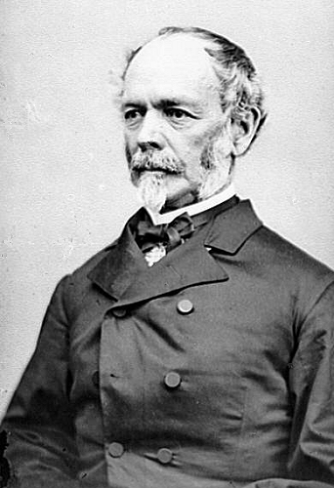
At the time of these new orders Johnston was in Tullahoma, Tennessee conducting a review of the command atmosphere surrounding another troubled Confederate leader, Braxton Bragg. Despite repeated complaints from subordinates, Johnston chose to ignore the problems regarding Bragg’s tenure as commander. By using a personal illness as an excuse not to seize control of the Army of Tennessee Johnston put off the distasteful task of relieving Bragg. The orders to Mississippi allowed Johnston to leave Tennessee without making what appeared to many of the field commanders the necessary change. The Army of Tennessee was left to the fate that Bragg would make for them. Bragg sent his benefactor a message of condolence concerning the new assignment;

“I feel most acutely for you, General, in the position in which you find yourself. Great ends to be secured, high expectations formed…”
Joseph E. Johnston

Johnston departed Tullahoma on the 10th with his personal physician in tow and headed off to Mississippi. He had been following the events in Pemberton’s command as closely as the telegraph messages from the local commander would allow. Attempting to direct the activities there remotely, Johnston encouraged Pemberton to be aggressive. He suggested that Pemberton challenge Grant if/when he crossed the Mississippi River. Contrarily Davis was instructing Pemberton to defend the city at all costs. Johnston arrived in the capital city on the night of the 13th and was briefed on the tactical situation by Gregg. Finding that he had only 6,000 troops on hand and three corps of the enemy between him and Vicksburg Johnston despaired. He wired Davis that he was “too late”.
Sent to Mississippi to stem the growing Union advance Johnston’s first decision was to abandon the city. He chose to give away the capital while waiting for reinforcements. He also sent messages to Pemberton (these were being reported to Grant before Pemberton even received them) to move toward a challenge to the Federal (Sherman) rear;

“To beat such a detachment would be of immense value; the troops here could cooperate; all the strength you can quickly assemble should be brought; time is all important.”

Once it became obvious that Grant was bypassing the city Johnston had repeatedly urged that Vicksburg and Port Hudson be evacuated to avoid the impending disaster. The overwhelmed Pemberton started out on the mission with little confidence. He believed that such a move violated Davis’ order to defend Vicksburg. Trying to please both masters he chose to leave two of his divisions (Forney and Smith) behind and advanced half heartedly with just three (Bowen, Stevenson, and Loring) to Edward’s Station. Retrospectively it is easy to see that the introduction of Johnston to the situation probably served to confuse Pemberton more than help. By attempting to obey both Davis and Johnston he degraded the possibility of pleasing either. In the post surrender finger pointing both Pemberton and Johnston would try to place the blame on each other.
Jackson, Mississippi (14 May 1863)
After the bloody engagement at Raymond Grant feared that a Confederate force was gathering at Jackson that would threaten his rear if he turned on Pemberton. He was determined that any effort against Vicksburg had to be preceded by the reduction of those forces. While McClernand kept an eye on Pemberton, who had move out to a position near Edward’s Station, McPherson marched north from Raymond to Clinton. Sherman moved through Raymond, trailing McPherson’s corps and marched to Mississippi Springs. Grant now had two corps in position to threaten the capital from different directions.
In Jackson, the newly arrived Johnston was planning the evacuation of the city. In order to gain time to remove the valuable military supplies from the city Johnston sent troops under Gregg to man the hastily prepared trenches. He also ordered Pemberton to attack Clinton to draw Union attention away from his activities. Pemberton realizing that there were four divisions of Federal troops in that area declined to do so. Grant could effectively disregard his presence.
At 0600 on the rainy morning of 14 May Sherman and McPherson began their march on the Mississippi capital. Their plan was a coordinated two prong attack on the city. Crocker’s division of led the way from the west and BG James Tuttle’s division of Sherman’s Corps from the southwest. Tuttle’s men had little difficulty driving the Confederate skirmishers before them “until we were within 2 ½ miles of Jackson where we encountered a heavier force with artillery.” Tuttle ordered the 2nd Iowa Artillery up to engage the enemy guns and a gun duel ensued. After thirty minutes the Confederate “battery was silenced” and the march continued until they reached the works on the outskirts of the city. There artillery from the works “opened a brisk fire upon us.” In there immediate front was a small force consisting of the 3rd Kentucky Mounted Infantry, a battalion of sharpshooters, and the gunners. Rather than attack head on Sherman ordered the lead units to ready for battle while the 95th Ohio conducted a reconnaissance to the far right of the Union line. The Buckeyes, under Colonel W. L. McMillen, found the trenches empty and were led by the Confederate guns by a contraband. McMillen’s men made prisoners of the gunners and nine guns while the remaining Confederate troops concluded they could delay the Union advance no longer and made good their get away. Sherman’s column “marched into town without further opposition.”
At the western approaches to town the Union forces were finding the going much tougher. Because they needed to protect the primary escape route along the Canton Road a much larger force was drawn up there. Colonel P. H. Colquitt, Colonel W. H. T. Walker, and Colonel R. Farquharson (commanding Gregg’s Brigade) had their brigades blocking the Clinton Road. At approximately 0900 Union troops from Holmes brigade of Crocker’s division collided with the Confederate skirmish line. The line “reluctantly and slowly fell back” on to the main line comprised of the 24th South Carolina, 46th Georgia, and 14th Mississippi supported by four guns of Hoskin’s battery. Holmes “commanded that bayonets be fixed and a charge made upon the enemy.” The bulk of the attacking force was made up of the 17th Iowa, 10th Missouri, and 80th Ohio. The fight swirled back to the O. P. Wright house where an “almost hand to hand conflict with the 24th Regiment South Carolina Volunteers” ensued. There the majority of the casualties for the entire action occurred. Ellison Caper’s stubborn South Carolinians reported 105 losses and the nearby 46th Georgia totaled 88. The 17th Iowa, 10th Missouri, and 80th Ohio accounted for 68% of the Union total of 300. At 1600 Gregg withdrew the last of the Confederate troops when he received word that the trains had cleared the city. The fight for Jackson was over
The fall of Jackson accomplished much more than it originally appeared. Besides pushing Johnston north to canton and farther away from consolidation with Pemberton and the destruction of the supply line to Pemberton Grant also stopped the flow of Confederate reinforcements to the area.
On 12 May there were nearly 10,000 troops headed to Jackson from as far away as South Carolina. All of these troops would have to pass through Jackson. When the city became untenable as a railhead these movements stopped where they were when they received the word that Jackson had fallen. When these movements stopped Johnston’s forces were effectively reduced from a projected 15,000 to the few that had moved to Canton from Jackson. This group did not pose a significant enough threat to prevent Grant from turning the bulk of his army toward Pemberton. They had ceased to be active players in the campaign for Vicksburg. As Sherman destroyed anything in Jackson of military value, McPherson and McClernand moved off to intercept Pemberton’s attempt to march to join Johnston.

Champion Hill – Genesis of Defeat
The evacuation of Jackson and subsequent retreat to Canton and beyond left Pemberton as the only legitimate force standing in the way of the ultimate prize – Vicksburg. Although Johnston had been reduced to a military non-factor his command influence was about to play a huge role in the coming events. His insistence on unifying the two commands would push Pemberton into a battle he did not want and was not prepared to win.
Johnston’s 13 May request that Pemberton strike the Federal rear at Clinton peeled the scab off the wound that was Pemberton’s command structure. Pemberton could not justify the action in his own mind given the orders from Davis to defend Vicksburg at all cost. He felt the move would open the way for McClernand’s Corps to assault the city. Despite these misgivings he wired Johnston:

“I move at once with the whole available force from Edward’s Station.”

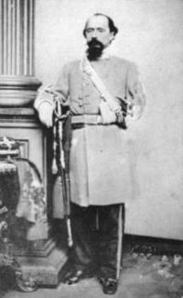
The movement had not yet begun when he had a change of heart and rescinded the order. He decided to open the matter for discussion and invited his commanders to a council of war on the 14th. The meeting turned rancorous as most of those present favored the planned advance. Pemberton continued to argue against it in the face of this dissent. Division commanders Loring and Stevenson eventually calmed the dispute by offering an alternative plan. They suggested that a move be made against Grant’s extended supply line to the south. Pemberton mulled the plan over and finally agreed. He notified Johnston of the new arrangement and began planning his move in pain-staking detail.
The proposed move revealed much about Pemberton’s lack of field experience and hidden under currents of discontent amongst his officers. Despite planning the move down to the number of yards between elements Pemberton failed to account for two critical elements of combat operations; logistics and reconnaissance. On the morning of the 15th it was discovered that there was not enough food or ammunition on hand to supply all the troops for the move. A train had to be dispatched to Vicksburg to pick up the necessary supplies to cover the difference. The march, originally slated to begin at 0800 did not set off until after 1300.
William Loring
The march was destined to be a short one. After only two miles Colonel Wirt Adams, in the van with his cavalry, discovered that the ford over Baker’s Creek had been made unusable by the heavy rains. No effort had been made to recon the site despite the short distance from the start point. Pemberton wasted two additional hours deciding what seemed obvious to his subordinates. They would have to detour to the bridge on the Jackson Road. During the delay the command atmosphere continued to erode. BG Tilghman, leading the main column with his brigade, somehow incurred the wrath of Pemberton and was placed under arrest and command given to Colonel Robert Lowery of the 6th Mississippi. When Loring heard of the affair he rushed to the defense of his subordinate. Although the story is disputed, Tilghman wrote in a letter that day that Loring told Pemberton that if he could do without Tilghman then he could do without him as well. Pemberton, facing an imminent engagement with the enemy, had no recourse but to revoke the order. According to Tilghman’s version of events the order was bitterly scribbled out on the pommel of Pemberton’s saddle.
The march moved on at 1600 when Pemberton finally adopted the move to the nearby bridge. The cumulative delays had restricted the march to just four miles in eight hours. As darkness fell camp was made in the vicinity of the Coker house around 2200 by the lead elements. The trailing units continued to arrive until 0300 on the 16th. Exhausted and disgruntled the Confederates were in for one more alteration in their designed move.
Champion Hill – Opening Moves (Loring’s Division)
While the Confederate column closed up near the intersection of the Raymond Road and the Ratliff Road on the night of the 15th Colonel Edward Goodwin was ordered to report to MG William Loring, the division commander. Loring ordered Goodwin out into the “deep dusk” to picket the Raymond Road about a mile in advance of the head of the column with his 35th Alabama Infantry. Also deployed was the 22nd Mississippi of LTC H. J. Reid. The two regiments straddled the road and Company F of the 35th was sent out “several hundred yards in advance.” In front of them Colonel Wirt Adams’ cavalry rode a distant picket in the vicinity of the Davis House. During the night only an “occasional gun was fired” and that by the cavalry picket.
About 0630 as Pemberton was meeting with Adams the skirmishing of the cavalry pickets became “very brisk”. Adams departed to assess the situation just as a message from Johnston was arriving. Johnston’s instructions were specific;

“Our being compelled to leave Jackson makes your plan impracticable. The only mode by which we can unite is by your moving directly to Clinton…”

Clinton, of course, was in the opposite direction of travel so Pemberton ordered;

“A retrograde movement, by reversing the column as it then stood, for the purpose of returning to Edward’s Depot to take the Brownsville Road…”

As the column was being reversed Colonel Adams’ pickets were driven in and a long range artillery barrage opened by the 17th Ohio Light Artillery. Despite the developments on the Raymond Road Pemberton decided to continue the counter march because he could not determine if “…this was an attack in force or simply an armed reconnaissance.”
It did not take long before activity became more serious and he was forced to order his division commanders to form a line of battle.
At the Raymond Road Goodwin rode forward to consult with Adams but before he could find the cavalry leader he saw his pickets being driven in by Federal cavalry with a “long battle line of infantry” behind them. He galloped back to form a line of battle just as the artillery bombardment began. Two Mississippians were severely wounded and the 22nd fell back in disorder.
At 0830 Loring ordered the two regiments to begin falling back to the main line. Taking command, Goodwin ordered one company of the 22nd and Company B of the 35th forward to cover the withdrawal. The remaining portion of the 22nd was sent back about 100 yards to reorganize. After accomplishing this, the whole started a slow retreat. A 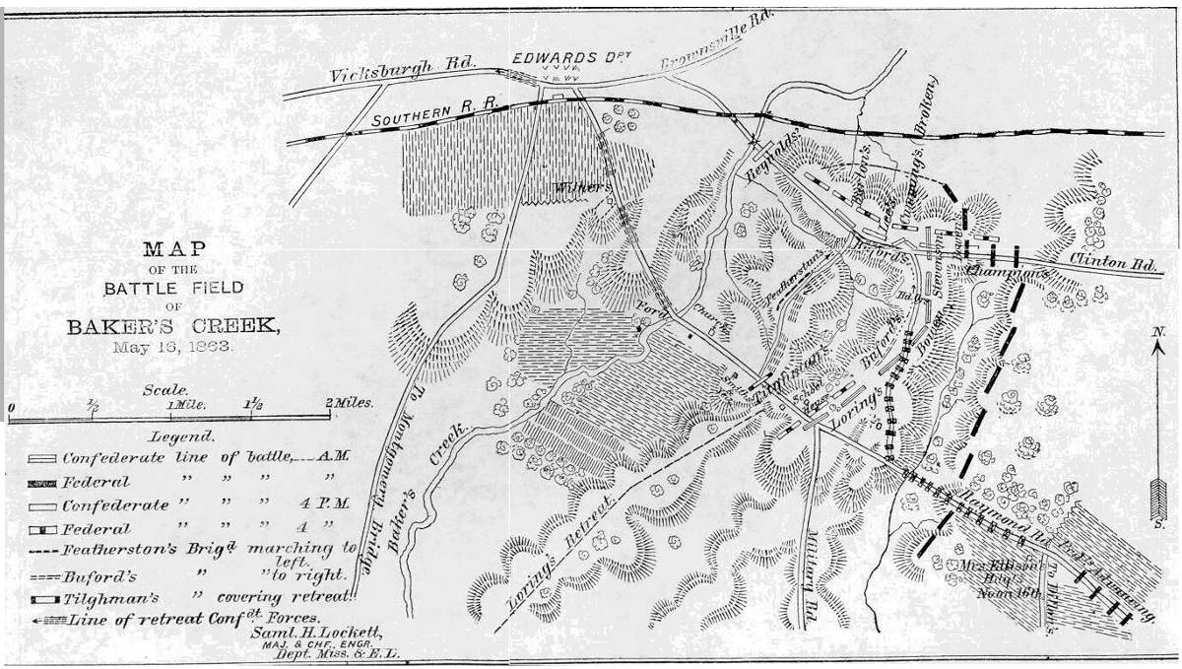second order from Loring arrived instructing Goodwin to being the two units back immediately. The units were quickly reunited with BG Abraham Buford’s brigade.
The approaching Federal infantry belonged to BG Stephen Burbridge’s brigade from BG A. J. Smith’s division. In front of Burbridge’s brigade were skirmishers from the 23rd Wisconsin. “They did most efficient service” pushing the Confederate skirmish line (35th Alabama and 22nd Mississippi) back onto the main line. As Burbridge’s command approached he recognized the main Confederate line, three brigades of Loring’s division, well established on the Coker House Ridge. The advancing line of blue came under “a most terrific fire of shot, shell, grape, and canister.” Burbridge sent back for help to even the odds. Reinforcements arrived in the form of the 19th Kentucky, 77th Illinois, and some additional artillery assets. The stage was set for a showdown on the Raymond Road when word came from BG Smith to halt.
Champion Hill – Opening Moves (Stevenson’s Division)
The reversal of the column in the fashion dictated by Pemberton left BG Carter Stevenson with a difficult problem. Since the slow moving trains traditionally trailed a march they were now in the front and blocking the advance of the army. Stevenson was ordered to move the wagons about three miles west on the Jackson Road and then park them on the far side of Baker’s Creek in a manner that would not impede the infantry and artillery. One regiment was to lead them while the remainder of the rear brigade secured the important crossroads of Jackson and Middle Road.
As the rear of the previous night’s column the brigade of Colonel Alexander Reynolds exhausted troops drew the task. The wagons were turned around and a line established near the intersection. A thick line of skirmishers was pushed out about 800 yards to the east on the Middle Road where cavalry picket activity indicated the greatest threat. Reynolds all Tennessee brigade held the line against light skirmishing until 0830 when the next brigade, under BG S. D. Lee, moved up to trade places according to the plan. Reynold’s took his troops and the 3rd Maryland Artillery to tend to the removal of the trains. They were successfully moved across the creek and a defensive perimeter established. Lee expecting trouble positioned Waddell’s battery to fire down the Middle Road and sent a company of the 20th Alabama to the area around the Champion farm to watch the Jackson Road.
About four miles north of the uneasy standoff at the Raymond Road the division of BG Peter Osterhaus was advancing westward on Middle Road. In front of the column rode a cavalry screen comprised of three companies (A, E, and K) of the 3rd Illinois cavalry, under the command of CPT John Campbell. These 90 men would make the initial contact with the Confederate forces near the intersection of the Middle Road and the Jackson Road. After locating the Confederate picket line they were dismounted and drove them back about a mile. While waiting for the infantry column to arrive Campbell received an order to conduct a charge. The mounted men passed through the Confederate skirmishers and directly into “three lines of battle on each side of the road” that opened a “galling” fire on the Union troopers. Captain Campbell, later noting that “no cavalry could long live” under such a fire, ordered a retreat which was “promptly executed.” Osterhaus sent Campbell and his men to open communication with BG Smith as the infantry took over the field.
The Union infantry was being led by BG Theophilus Garrard’s brigade. In front were skirmishers from the 7th Kentucky and 49th Indiana. They pushed the Confederate line back just as the Lee and Reynolds were swapping places. Momentarily stalled at the crossroads Garrard strengthened his line with the 69th Indiana and the 118th Illinois. As these units were deploying a messenger arrived at Lee’s headquarters from the detachment of 20th Alabama. BG Alvin Hovey was marching south down the Jackson Road with the lead elements of his division. Lee now faced a difficult decision. How to secure the critical intersection against the growing Union threat? Loss of the position would cut the entire army off from the intended route of march essentially trapping them between Grant’s three way pincers. Lee reacted quickly without consulting Stevenson.
“My brigade was at once marched by the left flank for the purpose of checking the enemy.”
Naturally the movement of Lee’s brigade created a large gap in the Confederate line. Lee sent a message back describing the situation and requesting help to extend his line. The closest available troops belonged to BG Cumming who had replaced him on the Middle Road. Cumming was at that moment meeting with Stevenson and the request was immediately approved. Three of Cumming’s Georgia regiments (34th, 31st, and 39th) sidled northward to fill the gap left by Lee’s departing Alabamans. The 56th and the 57th Georgia were left to secure the crossroads with Waddell’s battery. What had started out as a change of direction for the army’s march was rapidly becoming a gathering of forces for a set piece battle.
Champion Hill – Battle Developed (16 May 1863)
The Federal advance down Jackson road came to a stop when the cavalry advance (Company C 1st Indiana Cavalry) reported an enemy battery only 800 yards to the front.
The lead brigade of Hovey’s division, under BG George McGinnis, broke out of column formation and formed a line of battle with three of his five regiments (24th Indiana, 29th Wisconsin, and 11th Indiana) while the brigade of Colonel James Slack formed on his left. After deploying his troops McGinnis became concerned about the veracity of the report;

“After halting for some time and seeing no signs of the enemy…I determined to satisfy myself by personal observation…”

Sergeant Davis Wilsey, of Company C, personally escorted the general to the front and pointed out the enemy battery (most likely the Botentourt Virginia Battery) in question. His curiosity thus satisfied, McGinnis returned to his line and continued preparations for the battle he knew was imminent.
Despite gaining an advantage in the early troop deployments, particularly at the Jackson and Middle Roads, the Union commanders were being cautious. Although Hovey learned of Lee’s new position on the crest of Champion Hill he was not going to face the responsibility of “opening the ball” without proper authority. When his messenger found the Corps commander, MG John McClernand, on the Middle Road he deferred the matter to Grant, who was not yet on the field.
At 1000 Grant arrived on the scene, with son Fred, and established a command post at the Champion farm. Matilda Champion and her four children beat a hasty retreat for Bolton. Hovey, eager for the attack, was soothed by Grant, who told him to wait for Logan’s division of McPherson’s Corps to arrive. A short time later BG Mortimer Leggett, leading McPherson’s Corps, arrived and formed his brigade on the left with BG John Smith’s brigade falling in on their left. The third and final brigade of Logan’s division, under BG John Stevenson, was posted in reserve behind DeGolyer’s Michigan Battery. Another battery, 1st Illinois Light Artillery unlimbered in a tree line on the far right. With two divisions deployed and another on the way (BG Marcellus Crocker) Grant was ready to do battle.
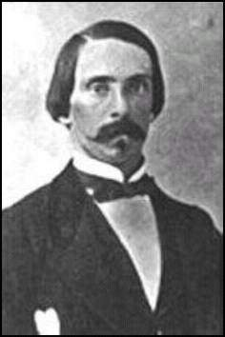
On the Confederate line BG Cumming bent back the right of his line to protect against any move from his right by repositioning the 36th Georgia and a portion of the 34th Georgia. Having barely set his line, the word was passed that Lee was advancing to the attack. To keep pace with the reported movement, which he could no see through the trees and intervening elevation, Cumming ordered his men forward. When he realized that the report had been a mistake he stopped his men and formed a new line. Unbeknownst to him his problems were being compounded when his skirmishers got bogged down in the rutted and wooded terrain and were actually positioned well to his right. He was without an early warning system. The timing could not have been worse for at that very moment Grant gave McClernand the order to attack.
BG Alfred Cumming
At 1030 Hovey and Logan lurched forward into an attack on Lee’s Champion Hill position. As the Confederate artillery opened McGinnis could not distinguish Lee’s main line through the trees and smoke and ordered his men to lie down. After a short delay while he conducted a leader’s reconnaissance he got his men to their feet and proceeded on with fixed bayonets. On his left two regiments (47th Indiana and 56th Ohio), part of Colonel James Slack’s brigade, struck the bent portion of Cumming’s line were greeted by volleys from the units at “the angle.” Hovey wrote in his official report that “at 11 o’clock the battle opened hotly all along the line.”

“Obstinate and Murderous Conflict” – Battle at Jackson Road
Without a warning from his misplaced skirmishers the Federal attack caught Cumming’s men completely by surprise. Fortunately for the Confederates on this part of the line the terrain and confusion caused by the badly located Confederate skirmishers broke up the two regiment front headed their way. Reacting to the report of enemy on his far left (three companies of Cumming’s skirmishers) the Union commander broke off a piece of his force to deal with the perceived threat. Nevertheless the Union formation was able to move within fifty yards of the Confederate line without being seen. The unexpected onset of battle at such close quarters shocked the men on both lines.
The first to regain their composure was the line of Georgians at the crest of the hill. Approximately 600 men poured out a volley, but having failed to compensate for the downhill nature of the fire many of the rounds passed harmlessly over the heads of the attackers. The Federals returned “a very heavy and destructive volley” that ripped into the Confederate line.
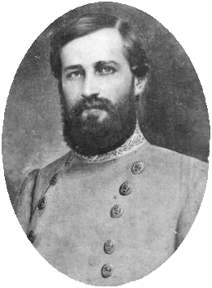
However, before Slack’s line could take full advantage of the situation at “the angle” orders came for the 47th Indiana to move to the right to support the attack on the main Confederate line. The respite was a short one for the Georgians. The 56th Ohio moved up to replace the departed regiment. The numerical superiority of the Union force eventually started to overcome the right side of Cumming’s line. A final charge into the position held by the Confederates changed the combat to a hand to hand struggle. The badly outnumbered Georgians battled the horde of attackers around them for a short time but finally had to give way. The 39th Georgia and the supporting companies of the 34th Georgia broke for the rear in a rout. The Botetourt Artillery and two recently arrived guns of Waddell’s battery were left undefended. The artillery horses became a prime target. With no means to remove the guns they were abandoned to be captured. The remaining troops of Cumming’s brigade were forced to retreat under the threat of envelopment.
The collapse of his right flank left Lee in a very poor position. His line was overlapped on the right by McGinnis and Slack’s temporarily disorganized men and the left was being threatened by the introduction of Stevenson’s reserve brigade. Additionally, on the far Union left three of Slack’s regiments (24th Iowa, 28th Iowa, and 56th Ohio) found themselves with an unimpeded route to the left flank of the 56th and 57th Georgia at the crossroads. Addressing the threat at the last minute, Colonel Elisha Watkins of the 56th, turned the two regiments and the remaining four guns of Waddell’s Battery to face north.
It was no contest. After an initial volley by the Georgians the three Federal regiments swarmed the position. The small Confederate line broke and fled across Middle Road to the south. Once again the artillery was left to their own devices. A frantic attempt to limber the guns proved unsuccessful. Again the horses became the primary targets. As they were shot down the gunners to haul the pieces off by hand. They suffered the same fate as the animals. Finally the survivors fled leaving the four guns in Union hands.
Stephen D. Lee
Only Lee’s brigade stood in the way of complete Union victory north of Jackson Road. He faced the three brigades of Logan’s division and the disorganized line of McGinnis’ brigade from Hovey’s division. The Union attack here did not surprise Lee’s Alabamans. The center of Logan’s attack was brought to an abrupt halt under a blistering fire. The Union line was free to operate around both of the flanks however. Division commander Stevenson called on his final brigade (Barton) to bolster Lee’s endangered line. While waiting for reinforcements to arrive Lee went back to the road and helped reorganize about 400 men, mostly of the broken 34th Georgia. These were hustled back to the main line where they were placed in line to support the 31st Alabama. Lee now became determined to silence the Union batteries that were playing havoc on his line. He detailed the 23rd Alabama to attack the guns. It was a brave but foolhardy effort. The Alabamans were mowed down by the 45th Illinois and 23rd Indiana in the front and the 24th Indiana from their right. Another briefly successful counterattack was conducted by the 46th Alabama. Their success proved to be their downfall. One by one Lee’s remaining regiments started to falter until it became obvious that Barton would not arrive on time. In their newly gained advanced position the 46th Alabama could not receive the retreat order. They were surrounded and most of the regiment was forced to surrender. The remainder of the brigade fell back to a new position just north of the east-west portion of the Jackson Road.
In roughly four hours of brutal fighting the Confederates had been pushed out of the most important position on the field and had lost much of their artillery. The situation was indeed looking grim for Pemberton.
Champion Hill – Barton Counter-Attacks (16 May 1863)
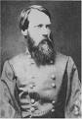
Although BG Seth Barton’s brigade arrived too late to save the original Confederate line, his troops were unbloodied and eager to impact the scene. The men were winded by the dash to Lee’s assistance but formed quickly to the right of Lee’s new position. Problems arose almost immediately. The absence of the 42nd Georgia and a section of guns from the 1st Mississippi Light Artillery (sent to cover the bridge early on) left the line woefully short. Instead of being anchored on a fine natural barrier (Baker’s Creek) his left was “in the air” about 600 yards short. The 42nd could not be recalled without leaving the critical bridge undefended. At this point the bridge represented the only escape rout from the rapidly deteriorating Confederate position. Furthermore, the short line was already being over lapped by the 81st Illinois, 32nd Ohio, and the 8th Illinois of Stevenson’s brigade.
Barton adjusted to accommodate the situation as best he could with the available resources. The Parrott rifles (4) of Corput’s Cherokee Artillery were set at the left on the road, supported by the 52nd Georgia. Shortly after dropping trail they were joined by a section of Napoleons from Ridley’s 1st Mississippi Light. Thinking his left now secure (he had badly underestimated the threat) Barton decided to assume the offensive. The 40th, 41st, and 43rd Georgia charged into the strength of BG John E. Smith’s brigade that had just completed the successful flank attack on Lee’s original line. At the focal point of the attack were Colonel Manning Force and his 20th Ohio Infantry. Dedicated journal keeper Sergeant Osborn Oldroyd of that regiment recalled that the attack “succeeded in driving us a short distance” but with the help of the nearby regiments the attack was driven back.
BG Seth Barton
While Barton conducted his counter-attack the 52nd Georgia was left with the six guns to stop BG John Stevenson’s flanking movement. Colonel Charles Phillips, regimental commander of the 52nd, also decided to assume the offensive. He attacked the approaching horde of Federals. This attack was absorbed primarily by the 124th Illinois while the 81st Illinois and the 32nd Ohio focused on the guns. The artillery men were no match for the overwhelming numbers that were bearing down on them. There were few survivors amongst the gunners as the batteries fell to the Union charge.
His flank now collapsed, Barton was caught in a trap of his own making. His three advanced regiments were now surrounded. It was fight or flee and most decided on the latter. As Barton stated in his report;

“The brigade had been terribly handled.”

A withdrawal was ordered but Barton admitted that;

“…the movement was necessarily accompanied with some confusion.”

1LT George Durfee of the 8th Illinois was less complimentary, stating in a letter home that the Confederates had been driven “like sheep” from the field. Whatever the case the Confederate loss here was considerable. Barton would later estimate his losses, including the unengaged 42nd Georgia; at 42%.Those lucky enough to avoid the closing Federal pincers retreated in disorder south of the Jackson Road. The road was cut by Stevenson’s victorious troops. The supply wagons that had been sent to the far side of the creek were now isolated from the elements that they were intended to support. A resupply of ammunition would not be forthcoming for the hard pressed Confederates.
Champion Hill – Bowen’s Counterattack
Near the cross roads of Jackson and Middle Road MG John Bowen’s small division, that had remained relatively inactive during the early fighting, was now forming a line south of the intersection. Colonel Cockrell’s Missourians formed on the west side of the Ratliff Road and BG Martin Green’s brigade on the east. The Missouri Battery of LT John Langan, reduced to two guns by losses suffered tin the long range duel earlier, went into action near the crossroads. They were quickly joined by Lowe’s Missouri battery of four guns. Never one to shy away from a fight Cockrell colorfully described what happened next.

“I ordered the brigade to charge the heavy, strong lines of the enemy, rapidly advancing and cheering, flushed with their success, and the capture of our guns, and in the most gallant, dashing, fearless manner, officers and men with loud cheers threw themselves forward at a run against the enemy’s hitherto victorious lines.”

Unfortunately the assault was not well coordinated with Green, who was not yet fully deployed for the attack. Bowen rode to the rear of Green’s line and emphasized the need for concerted action. In a rush to make up the distance lost Green’s men and the remnants of the 56th and 57th Georgia blocked the firing lane for Lowe’s guns. The artillerymen simply faced the guns east and continued to hammer away at Osterhaus’ men still waiting on the Middle Road.
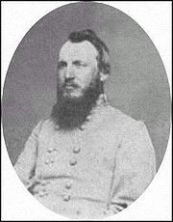
The Confederate wave hit the brigades of McGinnis and Slack as they were attempting to reorganize from their attack on Cumming’s brigade. Because he departed without Green, Cockrell’s far right was enfiladed by the temporarily unoccupied troops of Slack’s brigade. The 1st Missouri withstood the pounding until Green’s attack struck Slack’s men squarely in the front. On the right of Slack’s line the 24th Iowa stood firm for about fifteen minutes before they were forced to fall back. On the left the 28th Iowa had already broken. The 56th Ohio was left by itself and flanked on both sides. The retreat became a rout with the fleeing Federals forced to make their way over several hundred yards of open ground to get to the rear. The 56th suffered badly as they made their way over the killing ground.
Colonel Francis Cockrell
On the Confederate left Cockrell was also having his share of success. Although McGinnis men were not routed they were still falling back. During the fighting withdrawal McGinnis sent couriers to the rear with a desperate call for reinforcements. He attempted to hold the gray wave back while help was ordered forward. Inspired by Cockrell’s and Green’s success Barton and Cumming rallied their men and joined in the attack. The lost guns were recovered and reversed again. Waddell and the few remaining artillerymen put them to work against the retreating Union line.

Help began arriving for McGinnis in the form of BG Marcellus Crocker’s division and a rather disorganized passage of lines was conducted with McGinnis’ badly rattled troops by Colonel George Boomer’s brigade. Confusion in the orders left them susceptible to a deadly enfilading fire from Green’s men on their left flank. Colonel John Sanborn’s brigade was thrown in on Boomer’s right when it appeared on the field. Despite the increased manpower the attempted counter attack was stalled by Cockrell’s men. The two sides stopped moving “and killed each other as fast as we could.”
Green and Cockrell were more than holding their own against the rapidly growing federal strength. Green came dangerously close to turning Boomer’s flank until beaten back by heavy concentrations of Union artillery and the arrival of Colonel Samuel Holmes brigade. The Confederate brigades were now seriously short of two vital assets; ammunition and reinforcements. Neither would be forthcoming. Ammunition was desperately needed but as Cockrell put it;

“In the early part of the engagement I sent two of my staff officers for ammunition but the ordinance train could not be found.”

Colonel Thomas Dockery, 19th Arkansas, reporting Green’s brigade reported that Green responded to his request fro ammunition by stating;

“…the ordinance train had been ordered from the field.”

Despite the lack of ammunition Cockrell was determined to keep up the fight. He reported;

“…received a notice…that there was an order to retreat, which I delayed communicating hoping that MG Loring’s division might still arrive.”

Where was Loring’s division? That was the question.
Champion Hill – Command Problems
As the battle developed Grant was having problems with a balky subordinate. Although he had divisions poised on both the Middle Road and Raymond Road MG John McClernand was acting very cautiously thinking that he was in compliance with Grant’s command directive. Grant, however, felt that he was too idle and at 1235 an order was sent urging McClernand “to feel and attack the enemy in force, if opportunity occurred.”
The order did not reach McClernand until 1400. At 1430 Osterhaus’ division was still preparing for battle despite having been on the scene since early morning. When Bowen’s attack set off, Green’s right flank was totally exposed to McClernand’s Federals not 800 yards away yet no movement was initiated. A flank attack at this point might have destroyed Green’s attack before it could gain full momentum. Instead no large scale movement by the troops on either road was begun until the Confederate retreat was started. A huge opportunity had gone unfulfilled.
Across the field Pemberton was also having troubles with one of his corps commanders. When he realized that the main Union effort was at the Jackson Road intersection he knew that reinforcements would be necessary there. As early as 1400 orders had been sent for Bowen and Loring to begin moving north to assist Stevenson’s hard pressed men. An additional request went to Loring instructing him to stay closed up on Bowen’s division as they deployed for their attack on the Ratliff Road.
Confident that there was “no important force” threatening Loring’s position, Pemberton sent several staff officers with orders for him “to move all but one brigade (Tilghman’s to hold the Raymond Road and the lower crossing) to the left as rapidly as possible.”
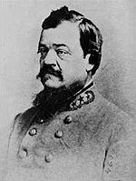
Replying to Pemberton, Loring stated that such a move would be unsound because he was being pressed “in strong force” in his front and was being flanked. Pemberton became suspicious when he could not hear firing in that direction and sent a repeat order. The time wasted on the courier messages worked in favor of the Federals and they “did not fail to take advantage of” the gift.
At 1600 as Stevenson’s line began falling apart Pemberton decided to take matters into his own hands and rode off in search of Loring personally. He discovered BG Abraham Buford’s brigade finally moving north near the Robert’s House. He ordered Buford to move west along the Jackson Road. As they passed Pemberton also picked out Colonel Thomas Scott’s 12th Louisiana and sent them alone to cover Green’s right flank at the crossroads. Buford’s regiments would be pilfered again without his knowledge when Bowen ordered the 35th Alabama to the crossroads as well. The two regiments would perform yeoman duty during the coming retreat.
BG Abraham Buford
When Buford arrived at Stevenson’s position he found little in the situation that could be redeemed with his small force. Bowen’s troops had already begun to fall back and the situation at Stevenson’s position was even more chaotic. Lee and Cumming’s men were fleeing the scene. Try as they might they could not rally the retreating men and “the flight became precipitate.” Pemberton ordered them “to hold the road immediately in rear of General S. D. Lee’s brigade. He decided that attempting to form a line north of the road would be impossible under the existing conditions Buford took a position just south of the road with his abbreviated brigade. Pemberton had no choice but to order a general retreat or take the chance of losing the remnants of his army.
Cockrell’s hope for assistance from Featherston’s brigade proved a false one. Featherston reported that “about 2 or 3 o’clock” he received orders from Loring to move to the Jackson Road. “We had a guide, who carried us the nearest way.” The road selected by the unnamed guide was an obscure country lane that was a considerably longer route than the Ratliff Road. The extended length of the march would not allow them to arrive in time to help Cockrell. Pemberton had no choice but to order a retreat or take the chance of losing the remnants of his army.
Champion Hill – Retreat
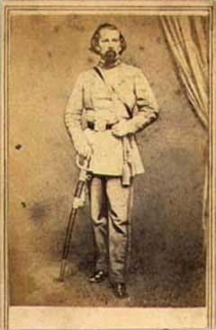
Pemberton’s order to retreat was hardly more than a formality. The broken remnants of Stevenson’s and Bowen’s divisions were already streaming to the rear. The tardy but finally arrived brigades of Buford and Featherston were ordered to secure the escape route to the lower crossing of Baker’s Creek. On the Raymond Road Loring’s third brigade, under BG Lloyd Tilghman, was to hold back any Union advance if escape was to be possible.
Loring finally made his presence on the field felt by his skillful handling of his two northern brigades during the chaotic situation near the Jackson Road. Amidst a stampede of wagons, horses, stragglers, and wounded trying to make their way out of the Union vise Loring established Featherston in a blocking position with Buford on his right. Stevenson’s badly used up men led the march southward.
To the east Bowen’s battered division moved back while Buford’s two pilfered units, 12th Louisiana and the 35th Alabama, conducted a heroic delaying action against Osterhaus’ division that had finally been released by for action on the Middle Road. Colonel Thomas Scott and his Louisiana regiment were stationed at the critical crossroads where he found Green’s brigade “retiring from the field in great confusion.” As he formed a line of battle Osterhaus’ lead regiments came to life. The 49th Indiana and the 42nd Ohio were advancing west just north of Middle Road. Although he was greatly outnumbered Scott ordered a bayonet charge into the Union line. The attack so unsettled the 42nd Ohio that they began to fall back. The 49th Indiana bore the brunt of the charge alone. “After passing a few blows with the butts of their pieces” Colonel James Keigwin’s Hoosiers retried to a small elevation and reestablished the firepower advantage and forced Scott to retire. The 12th Louisiana had stopped a brigade sized advance it its tracks with its bold effort. A similar scenario was occurring south of the road. Colonel Edward Goodwin’s 35th Alabama supported by a battery of guns delayed another Union move to seal off the route of retreat. Both Scott and Goodwin rejoined Buford’s brigade after their important contribution and moved southwest to the bridge recently completed by Major Samuel Lockett and a detailed regiment (42nd Georgia of Barton’s brigade) at the lower crossing.
BG Lloyd Tilghman
BG Lloyd Tilghman faced a severe challenge holding the Raymond Road when BG A. J. Smith got his division moving forward after a day long bout of skirmishing. After a brief move away from Coker House Ridge based on a missing countermanded order he was returned by Pemberton to a new position several hundred yards behind the previous one. It was essential that any Federal advance west down the Raymond Road be stalled long enough for the retreating army to cross Baker’s Creek behind them. Tilghman’s Mississippians stood up to the challenge holding back two brigades of Union troops. The action cost Tilghman his life but spared thousands of Confederate soldiers who would have otherwise been trapped.
The upper crossing was still held by the remnants of Barton’s brigade but was abandoned when they mistook reinforcements sent by Pemberton as Union forces. Reynolds’ brigade, still with the trains, were attacked by artillery fire from DeGolyer’s Michigan guns but managed to outmaneuver their Union pursuers until darkness provided enough cover to make it across the Big Black River at 0300 on the 17th.
At the lower crossing the situation became tense with the upper crossing now in Federal hands it was only a matter of time before they would be challenged from above. Bowen’s riddled regiments held the bridge as long as they thought reasonable waiting for Loring’s division to pass over. When Loring did not show and the threat from the upper crossing became too much Bowen ordered his men west. Loring’s men were trapped by a box of Union troops on three sides. Their salvation came when a local man, Dr. W. B. Williamson, arrived to guide them to another ford about three miles below. After an all night march through the lowlands Loring found the lower fords unusable with the far side already in Federal hands. Loring made the controversial decision to abandon the effort to rejoin Pemberton and turned his forces east to make a run for Johnston’s command instead. On May 19th he arrived at the capital which had been reoccupied after Sherman’s departure.
The Battle of Champion Hill ended as a resounding Union victory but it was not the end of the line for the battle weary men of both sides. Only hours separated them from their next encounter.
The Big Black River
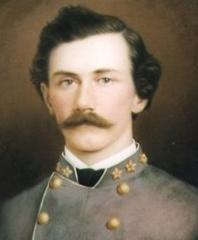
Pemberton moved his army back to the last natural obstacle between Grant and Vicksburg; the Big Black River. There he was determined to make a stand awaiting the arrival of Loring’s lost division. In preparation for the crossing Pemberton had the railroad bridge “floored for the passage of even artillery and wagons.” A second bridge was cleverly created by chief engineer Major Samuel Lockett by stripping the steamer dot of her machinery and setting her across the stream. The banks were cut and ramps built to supply passage across the river. Pemberton’s available forces were also increased by the appearance of BG John Vaughn’s Tennessee brigade which had come out from the Vicksburg defenses. These men were deployed on the east side of the river along with Bowen’s exhausted troops. A series of “skillfully constructed rifle pits” was made from dirt covered cotton bales. All that remained was to wait for Loring’s arrival.
Grant was in no mood to wait. He had the Confederate army on the run and intended on keeping it that way. He ordered the divisions of BG Eugene Carr and BG Peter Osterhaus to continue the march west at 0330. The skirmishers, the 33rd Illinois, almost immediately stumbled on to a large group of sleeping Confederate stragglers and made them all prisoners. At daybreak the 33rd made the first contact with the Confederate skirmishers at the bridgehead. Union forces deployed along the edge of a large open area with a natural moat formed by a “slough or bayou” between the two lines. “A spirited artillery engagement” began and one of the first casualties was BG Osterhaus who was directing his artillery. He was taken from the field with a thigh wound and command of his units passed to BG Albert Lee.
Major Samuel Lockett
Sensing that the terrain in their front “made advance over this ground impracticable” Lee searched for a way to flank the enemy position. On the far right of the Union line 2nd Brigade of 14th Division (Carr) was sent to see what advantage might be gained there. BG Michael Lawler sent the 11th Wisconsin and 23rd Iowa forward screened by two companies of skirmishers. They gained a position at the bayou but became bogged down by the heavy fire from the Confederate fortifications. Colonel William Kinsman, commander of the 23rd Iowa offered a solution to the stalemate; a bayonet charge into the enemy works. Before Lawler would consent to such a bold plan he reinforced the two regiments with the 21st Iowa and placed the 22nd Iowa in reserve. The men were instructed to “reserve their fire until upon the rebel works.” At about 0900 Lawler’s men jumped up from their positions with a shout and charged. They were greeted with a storm of lead. In the three minutes it took to rush across the 400 yards of ground between the two lines Lawler’s men suffered 199 casualties (14k, 185 w) or 80% of all Union losses for the entire fight. The survivors of the assault across the field mounted the works. Vaughn’s Tennessee brigade collapsed, the entire lot fleeing or surrendering on the spot.
Only Green’s Arkansas brigade made any effort at resistance but that brief. The entire Confederate line dissolved into a mad race to the bridges. On the far right of the Confederate line three regiments of the Tennessee brigade (60th, 61st, and 62nd) attempted to sneak away to the south on the east bank of the river. They ran into Burbridge’s brigade that had deployed to find the Confederate flank there and nearly all were captured.
Lockett saw the developing crisis and ordered the bridges fired. Union troops were kept from the burning spans by rifle fire coming from the bluff on the west bank. Those Confederates left on the east side of the river had a difficult choice to make; surrender or swim for safety. Many attempted the latter and some were drowned in the process. The bridges were completely destroyed and Federal pursuit momentarily halted.
The brief engagement was another spectacular Union victory. Grant’s forces had grabbed up 1,751 prisoners, 18 pieces of artillery, and five battle flags for the cost of fewer than 300 casualties. The river would form a barrier only as long as it took to bring up the Union engineers. One of the most ingenious bridges of the war was built by Andrew Hickenlooper, chief engineer of McPherson’s corps. Using cotton bales as the base of a floating bridge Hickenlooper had XVIIth Corps over the river by early morning on the 18th.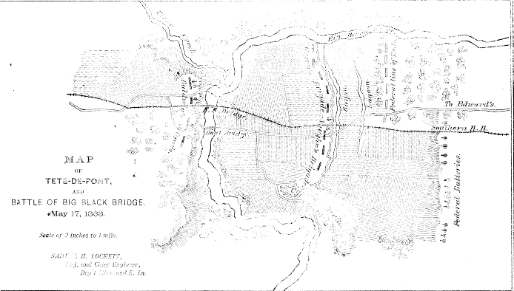
In an interesting sidelight to the one-sided affair Grant was approached by BG William Dwight, of MG Nathaniel Banks’ staff. He was carrying a dispatch from Henry Halleck dated 11 May suggesting that they combine forces. The concept of sharing part of his command with the incompetent Banks appalled Grant. Having already abandoned that course once he was not about to readopt it in the face of success. Dwight insisted that the message represented a direct order from Halleck and it must be obeyed. In the midst of their discussion Lawler’s attack began and Grant rode away from the unsatisfied Dwight. There would be no unification of forces when Vicksburg lay within striking distance.
Pemberton’s men stumbled into Vicksburg broken, disorganized, and demoralized. The civilian population was shocked at what had become of the army. Throughout the day of the 17th a chaotic scene ensued as “wagons, cannon, horses, men, mules, stock, sheep, and everything you can imagine that appertains to an army” was brought into the city. Pemberton received a message from Johnston advising him to abandon the city and escape while the opportunity still existed. The Confederate commander called another council of war and it was decided to stay and defend the city. Johnston had neither the forces nor the will to do anything to help Pemberton now and informed Jefferson Davis that the city was doomed.
Grant wasted no time taking advantage of the unexpectedly easy victory at the Big Black. Early on the 18th all three corps were on the march. Sherman’s XVth Corps had rejoined the army and had crossed the Big Black on their pontoon bridge some miles to the north. He approached Vicksburg by way of the site of his bloody repulse the previous year. He dispatched a regiment of cavalry (4th Iowa Cavalry) to come in behind the Confederate fortifications at the bluff. They found the line deserted but took possession of 13 heavy guns that had been left behind. All available troops were being shepherded into the main line of defenses around Vicksburg.
Grant’s three corps began moving into positions around the northern two thirds of Pemberton’s line. A full envelopment was deemed unwise and unnecessary by Grant. To extend his resources to cover the entire line would leave portions dangerously weak and an escape effort to the south would only leave Pemberton trapped in the small triangle of land formed by the Mississippi and the mouth of the Big Black. He also concentrated on another critical aspect of the campaign. Having made contact with the Union warships on the Mississippi and Yazoo Rivers he now had the chance to a regular supply line. On the 19th the Yazoo River was bridged by his engineers opening the first steady supply stream since he had crossed the Mississippi on 1 May.
His men were now resupplied with food and ammunition but he still faced a daunting task. The Vicksburg defenses had been nearly a year in the making. They were well prepared to receive the Federal onslaught that the Confederate command knew was coming. Major Samuel Lockett, chief Confederate engineer, described the defenses this way;

“The line of defenses around the city of Vicksburg consisted…of a system of detached works (redans, lunettes, and redoubts) on prominent and commanding points, with the usual profile of raised field works, connected in some cases, by rifle pits…”

The Confederate army had been badly whipped for nearly three weeks but now the enemy had to come to them on ground of their choosing. Battered, demoralized, and outnumbered the Confederate soldiers in these works were still determined.
Nevertheless, Grant decided to go for the quick kill. Thinking that the morale of the Confederate force following the Big Black fiasco made them ready for collapse he ordered an assault by elements of all three corps on the 19th. The attack proved a failure and was recalled after several hours of heavy losses. Grant was discouraged by the result, his first setback since the beginning of the campaign, but remained convinced that the city could be taken by storm. He was “determined to make another effort to carry Vicksburg by assault.” On the 22nd, after a two day pause to resupply and establish better communication with his dispersed command, he ordered another try. Again the attacks were bloodily repulsed all along the line. In the face of 4,000 casualties for the two efforts Grant was forced to change his mind. He noted;

“After the failure of the 22nd, I determined upon a regular siege.”

The 55 days were over. Although Vicksburg had not yet been gained it was obvious to even the Confederate high command that it was only a matter of time before the city would fall. Grant was well supplied and growing stronger. Inside the city the 47 day siege would reduce the population to eating rats. The city would capitulate on 4 July 1863.
This campaign is widely considered one of the turning points of the Civil War
Although eventual Union victory at Vicksburg was still 47 days away the roots of that victory were buried deep in the 55 days that preceded the siege. The dynamic campaign waged by Grant before the siege was a lightening bolt of kinetic activity that over whelmed a disjointed Confederate command structure. The results of the campaign would have effects far beyond the fall of one city. These are well known;
The surrender of Vicksburg isolated the final Confederate bastion on the Mississippi – Port Hudson. The city capitulated on 10 July giving complete control of the Mississippi River to Union forces.
The division of the Confederacy at the Mississippi River separated the trans-Mississippi states from the rest of the Confederacy. Actions there were conducted in an insulated sideshow that had little or no impact on events east of the river.
Too much emphasis has been placed on what the Confederacy lost and not enough on what was gained by the Federal forces. Obviously their objective had been gained but in the process of accomplishing that something else happened. One thing was abundantly clear at the conclusion of the Vicksburg Campaign. They learned how to win. After nearly three years of stalemate, losses, poor leadership, and bad plans a Union army in the west was transformed into a powerful winning machine by a tenacious and innovative leader. His aggressive, yet not wasteful, style inspired his subordinates and his troops. A new attitude of success was manufactured during these 55 days. The end product of this process was an army that understood what it would take to win and would apply itself that goal. It featured a leadership that took to heart the lessons this victory had to teach them. Integration of assets, command integrity, economy of force and movement, and attack discipline became watchwords of this cadre. They learned to move with alacrity, strike when the situation favored them, and preserve their most valuable asset, the army, when it did not. They learned how to create opportunities for themselves instead of waiting for an enemy mistake. They became an army that knew how to win and confident they would do so under leaders that they trusted. It is no accident that wherever they went success followed.
Grant moved on to rescue the grim scenario in Tennessee. Here he summoned his old warhorse, Sherman, and the two formulated another spectacular movement that changed the seemingly poor situation into a rout of another Confederate army. The Federal armies in the west, particularly the Army of the Tennessee became accustomed to victory.
Grant was sent to imbue this attitude in the Eastern armies while the leaders from the Vicksburg campaign continued to dominate in the west. Huge tracts of the Confederacy were gobbled up by the men who had mastered the military trade in Mississippi and Louisiana. The original strategic design of deep penetration into the Southern heartland from the west finally became a reality. The western armies would not stop until they found themselves poised behind the Army of Northern Virginia in North Carolina. Caught in the ever closing Union vise Lee had no choice but to surrender.

Bibliography

The War of the Rebellion: A Compilation of the Official Records of the Union and Confederate Armies
Volume XXIV, Parts I & II
Official Records of the Union and Confederate Navies in the War of the Rebellion
Volume XXIV
Books
Triumph & Defeat –The Vicksburg Campaign, Terrence J. Winschel
Champion Hill – Decisive Battle for Vicksburg, Timothy B. Smith
The Battle of Raymond – The Untold Turning Point of the American Civil War,
Dan Bokros
Grierson’s Raid, Tom Lalicki
Guide to the Vicksburg Campaign, Leonard Fullenkamp, Stephen Bowman, and Jay Luvaas
History of the Forty-Sixth Regiment Indiana Volunteer Infantry, Thomas Bringhurst
Confederate Military History of Louisiana, John Dimitry
The Defense of Vicksburg - A Louisiana Chronicle, Allan and Mary Richard
The Civil War in Louisiana, John D. Winters
Personal Memoirs, Ulysses S. Grant
Nothing but Victory-The Army of the Tennessee 1861-1865, Steven E. Woodworth
America’s Civil War –The Operational Battlefield 1861-1863, Brian Holden Reid

Military Studies
The Vicksburg Campaign – 1863, Captain W. R. Higgins, 1930
Joint Operations and the Vicksburg Campaign, Major John W. Tindall, 1993
Union Logistics in the Vicksburg Campaign, Major Mark S. Hurley, 1980
Engineer Operations during the Vicksburg Campaign, Major Robert M. Puckett, 1974
The Confederate Delaying Action at the Battle of Port Gibson – 1May1863,
Major George E. Cone, 2001
Operational Raid: Cavalry in the Vicksburg Campaign 1862-1863, CPT Paul C. Jussel
Staff Ride Handbook for the Vicksburg Campaign December 1862 - July 1863,
Dr. Christopher R. Gabel

Articles
The Battle of Raymond, Parker Hills
Battle of Raymond, Rebecca Blackwell Drake

Websites
http://www.historynet.com/americas-civil-war-colonel-benjamin-griersons-cavalry-raid-in-1863.htm/3

